JXSE v2.6
The JXTA Java™ Standard Edition Implementation

Programmer's Guide
by Jérôme Verstrynge

July, 2010

Trademarks
- Sun, Sun Microsystems, the Sun Logo, and Java are trademarks, registered trademarks, or service marks of Sun Microsystems, Inc. in the United States and other countries.
- All SPARC trademarks are used under license and are trademarks or registered trademarks of SPARC International, Inc., in the United States and other countries. Products bearing SPARC trademarks are based upon an architecture developed by Sun Microsystems, Inc.
- ORACLE is a registered trademark in the United States and other countries, of Oracle Corporation.
- Berkeley DB is a registered trademark in the United States and other countries, of Oracle Corporation.
- UNIX is a registered trademark in the United States and other countries, exclusively licensed through X/Open Company, Ltd.
- JXTA is a registered trademark in the United States and other countries, of Sun Microsystems, Inc.


Please Recycle

Table of Contents
Introduction 8
Acknowledgments 8
Highlights 8
Update 9
What Is New? 10
API Brush-Up 10
Instantiator 10
JXTA vs JXSE Packages 11
Configuration Objects 11
Connectivity 12
RendezVous Service Methods 12

Method isConnectedToRendezVous() 12
Endpoint Service Methods 13

Connection To Relay Peers 13

Ping – Is Reachable? 13

EndpointRouter & Route Controller 13
Connectivity Code Example 14

EDGE A 14

RENDEZVOUS A 16
Content Management 18
Client Side 18
Server Side 21
Metering Code 26
Generated Code & Configuration 26

Optimization & Dead Code Removal 27
NetworkConfigurator Setters & Getters 27
New Implementations of Cache Manager & SRDI Index 27
Cache Manager Implementations 28
SRDI Index Implementations 28
Selecting a New Implementation 28
OSGi Level 1 Integration 29
Using the OSGi Integration 30
Task Manager 31
TCP Layer Implementation 31
Reverting to the 'Old' TCP Implementation 31
What Goes? 31
ACL 31
Direct & Canonical Messengers 32
PROXY Configuration Mode 32
Some Clarifications 33
Advertisement Lifecycle 33
Seeds 33
Lifecycle 33
Rendezvous Auto-Start 34
Module & Service Lifecycle 34
About the Future 35
Route Selection 35
Mavenization & Dependencies 36
Mavenization 36
Directory Structures 36

Pom.xml Organization 36

Current Structure for Code 36

Additions To The Build Cycle 36
Kenai Artifacts 37
Dependencies 38
Under The Hood 39
Core Implementation Concepts 39
JXTA Loader 39
Default Module Implementations 39
Peer Group Global Registry 40
Peer Group Implementations 40

Starting the Network 41
SRDI Manager, Index & Cache Manager 41
& Cache Manager 41
SRDI Manager 42
SRDI 42
Cache Manager 42
Well-known Services 42

With a twist... 43
Transportation Layer 43

Message Transports 43

Message Sender 44

Message Receiver 44

Message Propagator 44

Messengers 44

Messenger Implementations 45
Endpoint Service 47

Using Message Transports 47

Retrieving Messengers 47

Incoming Messages 48

Diagrams 48

Messenger Methods Callers 48
Resolver Service 48
Discovery Service 49

Processing SRDI Messages 50

Switching between RENDEZVOUS/EDGE 50
Rendezvous Service 50

RendezVous Service Implementation 50

Standard RendezVous Service 51

PeerConnection 51

RendezVous Service Providers 52
Pipe Service 52
Simple Pipe Communication 53
PipeService – Create Input Pipe 53
PipeService – Create Ouput Pipe 53
OutputPipe Send 54

Bidirectional Pipe Communication 54
New JxtaServerPipe 54
New JxtaBibiPipe 54

JxtaSocket & JxtaSocketServer 54

JxtaMulticastSocket 54
PeerInfo Service 54
Membership and Access Services 55
About The Future 56
The JXSE Architecture 56
OSGi, Modules, Service & JxtaLoader 56

Suggestions 56
Multiple peers in same JVM & Test Driven Implementation 56
Simplifying The Transportation Layer 56
Authentication & Security 57
UDP & Connectivity 57
From Java 5 to Java 6 57
Release Infrastructure & Support Environment 58
Current Infrastructure 58

Default Community Seeds 58
Moving from Java.net to Kenaï 58
Appendix A: EndpointService Diagrams 60
Endpoint Service – getMessenger() 60
Endpoint Service – getMessengerImmediate() 61
Endpoint Service – getCanonicalMessage() 62
Endpoint Service – getDirectMessenger() 63
Canonical Messenger 64
Endpoint Service – getLocalTransportMessenger() 65
Message Sender – getMessenger() 66
From Messengers to MessageSenders 67
Hint Processing 68
Appendix B: Pipe Diagrams 69
Input Pipe 69
Output Pipe 70
Appendix C: Connection Monitor Example 71
Connectivity Monitor 71
DelayedJxtaNetworkStopper 82
Appendix D: OSGi Integration Study 83
Introduction 84
Reminder 85
Modules in JXTA/JXSE 85

Terminology 85
JxtaLoader 85
JXSE JxtaLoader 85
JXSE Module Life-cycle 86
OSGi 87
Bundle 87

Bundle Life-Cycle 88

Service 88

Publishing, Discovering and Binding 90

Standard Services 90

Limitations 90
Service Components 90
Overall Differences & Similarities 90
Feasibility 91
Scoping 91
JXTA/JXSE as an OSGi Service 91

Requirements 91
JXSE Modules as OSGi Service Components 91

Requirements 91
Loading JXSE User Modules as OSGi Service Components 91

Requirements 91
Conclusions 92

Introduction
This document is a follow-up on the JXSE 2.5 Programmers Guide. Its purpose is to describe the new features which have been made available as part of the 2.6 release of the JXTA implementation in the Java Programming language (JXSE). This release is also known as JXSE 2.6. It also clarifies some concepts introduced in the JXTA/JXSE 2.5 Programmers Guide and provides additional, updated or new information where necessary.
The basics of JXTA can be found in the JXSE 2.5 Programmer's Guide.
Acknowledgments
This document was written with direct and indirect contributions from Mike (Bondolo) Duigou, Iain McGinniss Lorenzo Bigagli, Valerio Angelini, Mike Cummings and Simon Temple.
I would also like to thanks all those who contributed code or other software engineering skills and knowledge to the 2.6 release since release 2.5 (in alphabetical order):
  - Adrian Ivan
  - Ariel Ro
  - Ben St. Pierre
  - Bernd (neunzert)
  - Cees Pieters
  - Daniel Brookshier
  - Iain McGinniss
  - James Todd
  - John Boyle
  - Lorenzo Bigagli
  - Mike Cumings
  - Mike Duigou
  - Mirron Rozanov
  - Mohamed Hamada
  - Qiang Zeng
  - Simon Temple
  - Valerio Angelini
  - William (Bill) Middleton
Highlights
- OSGi – JXSE can now be started as an OSGi bundle/service to access the NetworkManager. The Apache Felix OSGi implementation has been integrated in JXSE and can be used as the standard OSGi framework.
- Configuration Objects – A new set of configuration objects have been created as part of the introduction of OSGi in JXSE. These can easily be loaded or saved as XML documents, or via input and output.
- Task Manager – In order to reduce the consumption of Threads and other resources, a single task manager object has been implemented to use a single thread group. The code has been updated to use centralize task requests and thread consumption.
- Cache Manager – A new implementation of the cache manager based on Apache Derby and H2 is now available. These can replace the current standard b-tree file system implementation.
- SRDI – An in-memory implementation of the SRDI is now available.
- Maven – Three pom.xml files and a proper directory structure were existing code can be copied has been implemented.
- New TCP Implementation – A new implementation of the TCP layer based on the NIO Netty has been implemented.
Update
Latest guide information, updates and errata will be made available on our wiki.
What Is New?
This section introduces the new features implemented in the 2.6 release, in alphabetic order.
API Brush-Up
It is generally agreed that an API addresses the required functionality in a software application. It should be a framework guiding the implementation of these without restraining technical implementation choices.
When it comes to the JXTA/JXSE project, the API should reflect functionality described or implied by the JXTA Specification document. It should also cover all use cases (i.e., ways of using the application) making it practical to operate.
Unfortunately, the current status of JXTA/JXSE API does not fully meet these requirements . Some API code references implementation details (e.g. the impl packages). Some implementation code is also present in the API, while some implementation 'concepts' deserve to be taken up in the API. The API documentation is sometimes too technical or overly related to implementation code or concepts. The API is not always easy to learn, to use, to maintain or flexible enough to evolve. It sometimes leaves too many doors open for interpretation.
There are situations where code behavior is unpredictable. Some users have to read implementation code to understand the behavior of the API. In some cases (for example, query messages), users have to refer to implementation code, which against the idea that they should only refer to the API for their own applications.
The design could also be improved in order to avoid having the user implement what the API module can also do (for example XML document manipulation) and reduce the need for boilerplate code.
API Objects referencing Impl code
net.jxta.platform.NetworkConfigurator
net.jxta.platform.NetworkManager
net.jxta.peergroup.NetPeerGroupFactory
net.jxta.socket.JxtaSocket
net.jxta.socket.JxtaMulticastSocket
net.jxta.util.JxtaBiDiPipe
net.jxta.util.JxtaServerPipe
The API brush-up initiative aims at making the code more consistent and clean. There has been quite some debate about the necessity of this process in the JXTA community. Some questioned the utility of it, others raised concerns regarding the downwards compatibility with existing applications. Some were concerned that modifying an API can alienate users, while others argued that the opposite happens when performed properly. A survey of the JXTA community showed that apparently, no one has actually implemented their own version of the delivered JXTA API objects.
Performing an API brush-up is a complex task which can only happen over several releases. Some raised the possibility of creating a new API from scratch. Others intuition that this should happen through the integration of the OSGi framework. The debate is still open, but the effort has been started for release 2.6.
Some obsolete and already deprecated code has been removed from the API. Other code (such as methods for example), have been deprecated or created as necessary. More methods and classes will be deprecated and removed, or created, in future releases.
When API (or Impl) code is removed, it is first deprecated for at least one release version, before being definitely removed (or refactored). Where necessary, the Javadoc is updated to guide users towards alternative or new code. The corresponding issues are well documented in the issue tracker.
Instantiator
A new object called net.jxse.JxseInstantiator has been implemented in the API. The purpose of this class is to provide a mechanism to load Class object instances from their fully qualified name, for later instantiation using reflection. It can be used to instantiate implementation classes from within the API without having the API code referring to the implementation packages code.
The instantiator could be used in a future release to remove references to the implementation code from within the API. The Instantiator is already used to instantiate the OSGi framework.
JXTA vs JXSE Packages
Currently, the code is organized in net.jxta and net.jxta.impl packages. However, new net.jxse packages have been introduced in order to start separating the JXTA concepts (i.e., from the specifications) from their actual implementation.
Configuration Objects
A new set of configuration objects have been implemented to easily load and save network configurations in collaboration with the OSGi framework:
Level | Package & Class
API | net.jxta.configuration.JxtaConfiguration
API | net.jxta.configuration.JxtaConfigurationException
API | net.jxta.configuration.JxtaPeerConfiguration
API | net.jxta.configuration.JxtaTransportConfiguration
API | net.jxse.configuration.JxseHttpTransportConfiguration
API | net.jxse.configuration.JxseMulticastTransportConfiguration
API | net.jxse.configuration.JxseTcpTransportConfiguration
API | net.jxse.configuration.JxsePeerConfiguration
- JxtaConfiguration – This object represents the concept of configurations in JXTA implementations. It specifically inherits of the Java Properties object, which offers facilities to load and save registered properties either via InputStreams and OutputStreams, or via XML files.
By default, the Properties object does not load / save default values for properties. The JxtaConfiguration object has been enhanced to handle this issue.
- JxtaConfigurationException – This object represents a generic JXTA configuration issue.
JxtaPeerConfiguration – This object inherits of JxtaConfiguration and represents the JXTA peer configuration concept.
JxtaTransportConfiguration – This abstract object inherits of JxtaConfiguration and represents the JXTA transport configuration concept.
- JxseHttpTransportConfiguration – This object implements the JxtaTransportConfiguration object for the JXSE HTTP transportation layer implementation.
JxseMulticastTransportConfiguration – This object implements the JxtaTransportConfiguration object for the JXSE Multicast transportation layer.
JxseTcpTransportConfiguration – This object implements the JxtaTransportConfiguration object for the JXSE TCP transportation layer.
- JxsePeerConfiguration – This object implements the JxtaPeerConfiguration object for JXSE. It contains an intance of JxseHttpTransportConfiguration, JxseMulticastTransportConfiguration and JxseTcpTransportConfiguration that will be saved and restored automatically when it is saved and loaded. This object can easily be updated to handle future transportation protocols.
Until JXTA/JXSE 2.5, it was the responsibility of the NetworkManager and of the NetworkConfigurator to save and retrieve existing configuration. The new configuration objects provide an alternative way of setting and getting peer configurations. It is the responsibility of the user to load and save the JxsePeerConfiguration objects properly.
In the OSGi section, we will describe how to obtain a completely configured instance of the NetworkManager (and corresponding NetworkConfigurator) from a JxsePeerConfiguration object.
Connectivity
Several methods and features have been implemented in this release to facilitate the monitoring of connectivity of peers and peergroups. Some buggy and functionally useless methods have been deprecated too.
RendezVous Service Methods
Some rendezvous service methods have been modified as following, new methods have been added too:

Method | Comment
connectToRendezVous(...) | Deprecated since 2.5 – Connection to RDVs is managed by core code.
disconnectFromRendezVous(...) | Deprecated since 2.6 – Connection to RDVs is managed by core code.
getConnectedRendezVous() | Deprecated since 2.6 – This method contains bugs. It returns the list of EDGE connected to this peer when it is a RDV.connection to RDVs is managed by core code.
getDisconnectedRendezVous() | Deprecated since 2.5 – Connection to RDVs is managed by core code.
getConnectedPeers() | Deprecated since 2.6 – This method is functionally useless, since it does not provide the list of EDGE peer connected to this peer when it is a RDV.
getConnectedPeerIDs() | Deprecated since 2.6 – This method is functionally useless, since it does not provide the list of EDGE peer IDs connected to this peer when it is a RDV.
getLocalWalkView() | Deprecated since 2.5 – Method contains bugs.
challengeRendezVous(...) | Deprecated since 2.6 – Connection to RDVs is managed by core code.
getLocalRendezVousView() | New in 2.6 – Provides the list of RDV an EDGE is connected to, or the list of RDVs a RDV knows through its peer view.
getLocalEdgeView() | New in 2.6 – Provides the list of EDGES a RDV is connected to.

The deprecated methods will be removed in the next release.
Method isConnectedToRendezVous()
In earlier releases, the values returned by the isConnectedToRendezVous() method were ambiguous. It was false for RDVs, true or false for EDGE peers and true for ADHOC peers. In release 2.6, the behavior of this method changes:
- ADHOC – Such peers typically does not participate in peer group activities and does not establish lease connection to rendezvous, although they will propagate group messages whenever possible. They only use (LAN) multicasting as a means of communication.
As from release 2.6, a call to the isConnectedToRendezVous() method on their RendezvousService always returns false, instead of true before. This is consistent with the fact that ADHOC peers do not interact with infrastructure peers.
- EDGE – Such peers try (desperately) to connect and to remain connected to one and only rendezvous peer in their peer group. If 'their' rendezvous fails, they will automatically try to reconnect to another rendezvous (and may become one if autostart is enabled). They use all means of communication available.
A call to the isConnectedToRendezVous() method on the RendezvousService always returns true or false, to indicate whether they are connected to a rendezvous or not.
- RENDEZVOUS – These peers accept lease connections from EDGE peers and connect to other rendezvous as possible. They use all means of communication available.
As from release 2.6, a call to the isConnectedToRendezVous() method on their RendezvousService will return true if they are connected to other RDV peers, via their peerview, or false otherwise.
Some applications using older versions of JXTA/JXSE rely on the fact that the isConnectedToRendezVous() method returns true for ADHOC peers, in order to find out whether they were ready to perform peergroup activities. The motivation behind this is not clear, but these applications will have to update their code.
Endpoint Service Methods
A couple of methods related to connectivity have been added to the rendezvous service.
Connection To Relay Peers
Two new methods have been implemented regarding relay connectivity:
- isConnectedToRelayPeer() – This method indicates whether an EDGE peer is connected to a RendezVous. Otherwise, it always returns false.
- getConnectedRelayPeers() – This method returns a collection of the relay peer IDs this peer is connected to.
Ping – Is Reachable?
In release 2.5, the EndpointService contained a deprecated ping method. Usually, when a ping is performed, it is followed by some communication with the remove device.
A new method called IsReachable(PeerID pid, boolean tryToConnect) has been added to the EndpointService, and indicates whether the target peer is reachable.
- If tryToConnect=false, the method returns true if an active connection has already been established to the target peer, else it returns false.
- If tryToConnect=true, the method returns true if an active connection has already been established to the target peer, else it tries to establish a connection to the target peer. If this connection is successful, the method returns true, else it returns false.
Assuming that a peer is reachable, a Messenger can be retrieved from one of the getMessenger() methods in the EndpointService to send messages.
EndpointRouter & Route Controller
One additional method has been implemented in the endpoint service to retrieve the endpoint router, that is, the object capable of dealing with unresolved endpoint addresses (typically, for peers from which we only know about its ID). These objects implement the endpoint routing protocol.
- getEndpointRouter() – This method returns an EndpointRoutingTransport containing a special method on top of traditional transport methods: getRouteController().
RouteController objects handle routes to target peers. They offer five API methods:
- addRoute(RouteAdvertisement newRoute) – This method can be used to provide route hints to the system. The route controller will check them and return an integer code indicating the result of the operation (ok, already exists, failed, opened direct route, invalid route).
- getAllRoutes() – Returns all known routes.
- getRoutes(PeerID inPID) – Returns all known routes to a target peer.
- getLocalPeerRoute() – Returns a route to this peer.
- isConnected(PeerID pid) – Returns true when a direct route to a target peer is known.
- These endpoint service methods, together with the new rendezvous methods, can help users to test and debug connectivity issues in their applications.
Connectivity Code Example
The following pages provide new tutorial code examples to monitor connectivity status between peers. A NetPeerGroup and a child peer group is created on each peer.

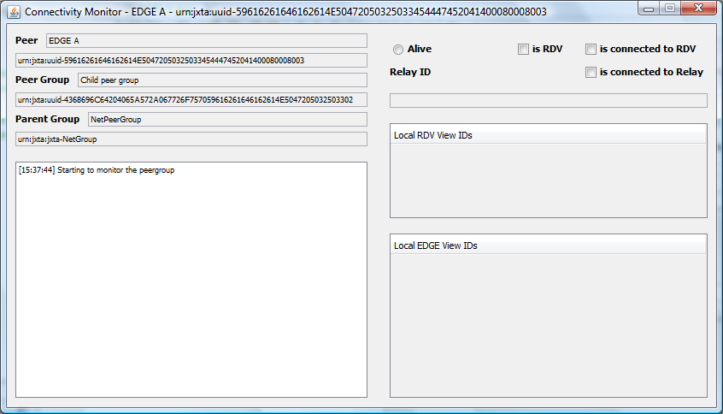
The examples refer to two other classes: ConnectivityMonitor and DelayedJxtaNetworkStopper. The code is available in the appendix.
EDGE A

/**
* Simple EDGE peer connecting via the NetPeerGroup.
*/
public class EDGE_A {

// Static

public static final String Name_EDGE_A = "EDGE A";
public static final PeerID PID_EDGE_A = IDFactory.newPeerID(
PeerGroupID.defaultNetPeerGroupID, Name_EDGE_A.getBytes());
public static final int TcpPort_EDGE_A = 9710;
public static final File ConfigurationFile_EDGE_A =
new File("." + System.getProperty("file.separator") + Name_EDGE_A);

public static final String ChildPeerGroupName = "Child peer group";
public static final PeerGroupID ChildPeerGroupID =
IDFactory.newPeerGroupID(PeerGroupID.defaultNetPeerGroupID, ChildPeerGroupName.getBytes());

/**
* @param args the command line arguments
*/
public static void main(String[] args) {

try {

// Removing verbose
// Logger.getLogger("net.jxta").setLevel(Level.WARNING);
Logger.getLogger(EdgePeerRdvService.class.getName()).setLevel(Level.CONFIG);

// Removing any existing configuration?
NetworkManager.RecursiveDelete(ConfigurationFile_EDGE_A);

// Creation of the network manager
final NetworkManager MyNetworkManager = new NetworkManager(
NetworkManager.ConfigMode.EDGE,
Name_EDGE_A, ConfigurationFile_EDGE_A.toURI());

// Retrieving the network configurator
NetworkConfigurator MyNetworkConfigurator = MyNetworkManager.getConfigurator();

// Setting Configuration
MyNetworkConfigurator.setTcpPort(TcpPort_EDGE_A);
MyNetworkConfigurator.setTcpEnabled(true);
MyNetworkConfigurator.setTcpIncoming(true);
MyNetworkConfigurator.setTcpOutgoing(true);
MyNetworkConfigurator.setUseMulticast(true);

// Setting the Peer ID
MyNetworkConfigurator.setPeerID(PID_EDGE_A);

// Adding RDV a as a seed
MyNetworkConfigurator.clearRendezvousSeeds();

String TheSeed = "tcp://" + InetAddress.getLocalHost().getHostAddress() + ":"
+ RENDEZVOUS_A.TcpPort_RDV_A;
URI LocalRendezVousSeedURI = URI.create(TheSeed);
MyNetworkConfigurator.addSeedRendezvous(LocalRendezVousSeedURI);

TheSeed = "tcp://" + InetAddress.getLocalHost().getHostAddress() + ":"
+ RENDEZVOUS_B.TcpPort_RDV_B;
LocalRendezVousSeedURI = URI.create(TheSeed);
MyNetworkConfigurator.addSeedRendezvous(LocalRendezVousSeedURI);

// Starting the JXTA network
PeerGroup NetPeerGroup = MyNetworkManager.startNetwork();

// Starting the connectivity monitor
new ConnectivityMonitor(NetPeerGroup);

// Disabling any rendezvous autostart
NetPeerGroup.getRendezVousService().setAutoStart(false);

// Retrieving a module implementation advertisement
ModuleImplAdvertisement TheModuleImplementationAdvertisement = null;

try {
TheModuleImplementationAdvertisement =
NetPeerGroup.getAllPurposePeerGroupImplAdvertisement();
} catch (Exception ex) {
System.err.println(ex.toString());
}

// Creating a child group
PeerGroup ChildPeerGroup = NetPeerGroup.newGroup(
ChildPeerGroupID,
TheModuleImplementationAdvertisement,
ChildPeerGroupName,
"For test purposes..."
);

if (Module.START_OK != ChildPeerGroup.startApp(new String[0]))
System.err.println("Cannot start child peergroup");

new ConnectivityMonitor(ChildPeerGroup);

// Stopping the network asynchronously
ConnectivityMonitor.TheExecutor.schedule(
new DelayedJxtaNetworkStopper(
MyNetworkManager,
"Click to stop " + Name_EDGE_A,
"Stop"),
0,
TimeUnit.SECONDS);

} catch (IOException Ex) {

System.err.println(Ex.toString());

} catch (PeerGroupException Ex) {

System.err.println(Ex.toString());

}

}

}
RENDEZVOUS A

/**
* Simple RENDEZVOUS peer connecting via the NetPeerGroup.
*/
public class RENDEZVOUS_A {

// Static

public static final String Name_RDV_A = "RENDEZVOUS A";
public static final PeerID PID_RDV_A =
IDFactory.newPeerID(PeerGroupID.defaultNetPeerGroupID, Name_RDV_A.getBytes());
public static final int TcpPort_RDV_A = 9711;
public static final File ConfigurationFile_RDV_A =
new File("." + System.getProperty("file.separator") + Name_RDV_A);

public static final String ChildPeerGroupName = "Child peer group";
public static final PeerGroupID ChildPeerGroupID =
IDFactory.newPeerGroupID(PeerGroupID.defaultNetPeerGroupID, ChildPeerGroupName.getBytes());

/**
* @param args the command line arguments
*/
public static void main(String[] args) {

try {

// Removing verbose
Logger.getLogger("net.jxta").setLevel(Level.WARNING);

// Removing any existing configuration?
NetworkManager.RecursiveDelete(ConfigurationFile_RDV_A);

// Creation of the network manager
final NetworkManager MyNetworkManager = new NetworkManager(
NetworkManager.ConfigMode.RENDEZVOUS,
Name_RDV_A, ConfigurationFile_RDV_A.toURI());

// Retrieving the network configurator
NetworkConfigurator MyNetworkConfigurator = MyNetworkManager.getConfigurator();

// Setting Configuration
MyNetworkConfigurator.setTcpPort(TcpPort_RDV_A);
MyNetworkConfigurator.setTcpEnabled(true);
MyNetworkConfigurator.setTcpIncoming(true);
MyNetworkConfigurator.setTcpOutgoing(true);
MyNetworkConfigurator.setUseMulticast(true);

// Setting the Peer ID
MyNetworkConfigurator.setPeerID(PID_RDV_A);

// Starting the JXTA network
PeerGroup NetPeerGroup = MyNetworkManager.startNetwork();

// Starting the connectivity monitor
new ConnectivityMonitor(NetPeerGroup);

// Retrieving a module implementation advertisement
ModuleImplAdvertisement TheModuleImplementationAdvertisement = null;

try {
TheModuleImplementationAdvertisement =
NetPeerGroup.getAllPurposePeerGroupImplAdvertisement();
} catch (Exception ex) {
System.err.println(ex.toString());
}

// Creating a child group
PeerGroup ChildPeerGroup = NetPeerGroup.newGroup(
ChildPeerGroupID,
TheModuleImplementationAdvertisement,
ChildPeerGroupName,
"For test purposes..."
);

if (Module.START_OK != ChildPeerGroup.startApp(new String[0]))
System.err.println("Cannot start child peergroup");

// Enable rendezvous
ChildPeerGroup.getRendezVousService().startRendezVous();

new ConnectivityMonitor(ChildPeerGroup);

// Stopping the network asynchronously
ConnectivityMonitor.TheExecutor.schedule(
new DelayedJxtaNetworkStopper(
MyNetworkManager,
"Click to stop " + Name_RDV_A,
"Stop"),
0,
TimeUnit.SECONDS);

} catch (IOException Ex) {

System.err.println(Ex.toString());

} catch (PeerGroupException Ex) {

System.err.println(Ex.toString());

}

}

}
Content Management
Shortly after Jxta 2.5 was released, a new means was implemented to exchange contents (for example files) between peers. It allows 'serving' peers to offer content to 'client' peers. The following pages describe how to use the content manager.
Client Side
package tutorial.content;

import net.jxta.content.ContentID;
import net.jxta.content.ContentService;
import net.jxta.content.ContentTransfer;
import net.jxta.content.ContentTransferEvent;
import net.jxta.content.ContentTransferListener;
import net.jxta.content.ContentTransferAggregator;
import net.jxta.content.ContentTransferAggregatorEvent;
import net.jxta.content.ContentTransferAggregatorListener;
import net.jxta.content.TransferException;
import net.jxta.id.IDFactory;
import net.jxta.peergroup.PeerGroup;
import net.jxta.platform.NetworkManager;
import java.io.*;
import java.net.*;

/**
* This tutorial illustrates the use of the Content API from the
* perspective of the client.
* <p/>
* The client will attempt to locate and retrieve a Content instance
* identified by a specified ContentID. Once the retrieval completes,
* the client will exit.
*/
public class ContentClient {

private transient NetworkManager manager = null;

private transient PeerGroup netPeerGroup = null;
private transient boolean waitForRendezvous = false;
private final ContentID contentID;

/**
* Content transfer listener used to receive asynchronous updates regarding
* the transfer in progress.
*/
private ContentTransferListener xferListener =
new ContentTransferListener() {
public void contentLocationStateUpdated(ContentTransferEvent event) {
System.out.println("Transfer location state: "
+ event.getSourceLocationState());
System.out.println("Transfer location count: "
+ event.getSourceLocationCount());
}

public void contentTransferStateUpdated(ContentTransferEvent event) {
System.out.println("Transfer state: " + event.getTransferState());
}

public void contentTransferProgress(ContentTransferEvent event) {
Long bytesReceived = event.getBytesReceived();
Long bytesTotal = event.getBytesTotal();
System.out.println("Transfer progress: "
+ bytesReceived + " / " + bytesTotal);
}
};

/**
* Content transfer aggregator listener used to detect transitions
* between multiple ContentProviders.
*/
private ContentTransferAggregatorListener aggListener =
new ContentTransferAggregatorListener() {
public void selectedContentTransfer(ContentTransferAggregatorEvent event) {
System.out.println("Selected ContentTransfer: "
+ event.getDelegateContentTransfer());
}

public void updatedContentTransferList(ContentTransferAggregatorEvent event) {
ContentTransferAggregator aggregator =
event.getContentTransferAggregator();
System.out.println("ContentTransfer list updated:");
for (ContentTransfer xfer : aggregator.getContentTransferList()) {
System.out.println(" " + xfer);
}
}
};

/**
* Constructor.
*
* @param id ContentID of the Content we are going to attempt to retrieve.
* @param waitForRendezvous true to wait for rdv connection, false otherwise
*/
public ContentClient(ContentID id, boolean waitForRendezvous) {
contentID = id;

// Start the JXTA network
try {
manager = new NetworkManager(
NetworkManager.ConfigMode.ADHOC, "ContentClient",
new File(new File(".cache"), "ContentClient").toURI());
manager.startNetwork();
} catch (Exception e) {
e.printStackTrace();
System.exit(-1);
}
netPeerGroup = manager.getNetPeerGroup();
if (waitForRendezvous) {
manager.waitForRendezvousConnection(0);
}
}

/**
* Interact with the server.
*/
public void run() {
try {
/*
* Get the PeerGroup's ContentService instance.
*/
ContentService service = netPeerGroup.getContentService();

System.out.println("Initiating Content transfer");
// Create a transfer instance
ContentTransfer transfer = service.retrieveContent(contentID);
if (transfer == null) {
/*
* This can happen if no ContentProvider implementations
* have the ability to locate and retrieve this ContentID.
* In most scenarios, this wouldn't happen.
*/
System.out.println("Could not retrieve Content");
} else {
/*
* Add a listener so that we can watch the state transitions
* as they occur.
*/
transfer.addContentTransferListener(xferListener);

/*
* If the transfer is actually an aggregation fronting multiple
* provider implementations, we can listen in on what the
* aggregator is doing.
*/
if (transfer instanceof ContentTransferAggregator) {
ContentTransferAggregator aggregator = (ContentTransferAggregator) transfer;
aggregator.addContentTransferAggregatorListener(aggListener);
}

/*
* This step is not required but is here to illustrate the
* possibility. This advises the ContentProviders to
* try to find places to retrieve the Content from but will
* not actually start transferring data. We'll sleep after
* we initiate source location to allow this to proceed
* outwith actual retrieval attempts.
*/
System.out.println("Starting source location");
transfer.startSourceLocation();
System.out.println("Waiting for 5 seconds to demonstrate source location...");
Thread.sleep(5000);

/*
* Now we'll start the transfer in earnest. If we had chosen
* not to explicitly request source location as we did above,
* this would implicitly locate sources and start the transfer
* as soon as enough sources were found.
*/
transfer.startTransfer(new File("content"));

/*
* Finally, we wait for transfer completion or failure.
*/
transfer.waitFor();
}
} catch (TransferException transx) {
transx.printStackTrace(System.err);
} catch (InterruptedException intx) {
System.out.println("Interrupted");
} finally {
stop();
}
}

/**
* If the java property RDVWAIT set to true then this demo
* will wait until a rendezvous connection is established before
* initiating a connection
*
* @param args none recognized.
*/
public static void main(String args[]) {

/*
System.setProperty("net.jxta.logging.Logging", "FINEST");
System.setProperty("net.jxta.level", "FINEST");
System.setProperty("java.util.logging.config.file", "logging.properties");
*/
if (args.length > 1) {
System.err.println("USAGE: ContentClient [ContentID]");
System.exit(1);
}
try {
Thread.currentThread().setName(ContentClient.class.getName() + ".main()");
URI uri;
if (args.length == 0) {
uri = new URI(ContentServer.DEFAULT_CONTENT_ID);
} else {
uri = new URI(args[0]);
}
ContentID id = (ContentID) IDFactory.fromURI(uri);
String value = System.getProperty("RDVWAIT", "false");
boolean waitForRendezvous = Boolean.valueOf(value);
ContentClient socEx = new ContentClient(id, waitForRendezvous);
socEx.run();
} catch (Throwable e) {
System.out.flush();
System.err.println("Failed : " + e);
e.printStackTrace(System.err);
System.exit(-1);
}
}

private void stop() {
manager.stopNetwork();
}

}
Server Side
package tutorial.content;

import net.jxta.content.Content;
import net.jxta.content.ContentID;
import net.jxta.content.ContentProviderEvent;
import net.jxta.content.ContentProviderListener;
import net.jxta.content.ContentService;
import net.jxta.content.ContentShare;
import net.jxta.content.ContentShareEvent;
import net.jxta.content.ContentShareListener;
import net.jxta.discovery.DiscoveryService;
import net.jxta.document.FileDocument;
import net.jxta.document.MimeMediaType;
import net.jxta.id.IDFactory;
import net.jxta.peergroup.PeerGroup;
import net.jxta.platform.NetworkManager;
import net.jxta.protocol.ContentShareAdvertisement;
import java.io.*;
import java.util.*;
import java.net.*;

/**
* This tutorial illustrates the use Content API from the
* perspective of the serving peer.
* <p/>
* The server is started and instructed to serve a file
* to all peers.
*/
public class ContentServer {

static final String DEFAULT_CONTENT_ID =
"urn:jxta:uuid-59616261646162614E50472050325033901EA80A652D476C9D1089545CEDE7B007";

private transient NetworkManager manager = null;
private transient PeerGroup netPeerGroup = null;
private transient boolean waitForRendezvous = false;
private final ContentID contentID;
private final File file;

/**
* Content provider listener used to be notified of any activity being
* performed by the contrnt provider.
*/
private ContentProviderListener provListener =
new ContentProviderListener() {
public void contentShared(ContentProviderEvent event) {
logEvent("Content shared:", event);
}

public void contentUnshared(ContentProviderEvent event) {
logEvent("Content unshared: ", event);
}

public boolean contentSharesFound(ContentProviderEvent event) {
throw new UnsupportedOperationException("Not supported yet.");
}
};

/**
* Content share listener used to be notified of any activity during
* a content transfer.
*/
private ContentShareListener shareListener = new ContentShareListener() {
public void shareSessionOpened(ContentShareEvent event) {
logEvent("Session opened: ", event);
}

public void shareSessionClosed(ContentShareEvent event) {
logEvent("Session closed", event);
}

public void shareAccessed(ContentShareEvent event) {
logEvent("Share access", event);
}
};

/**
* Constructor.
*
* @param toServe file to serve
* @param id ContentID to use when serving the toServer file, or
* {@code null} to generate a random ContentID
* @param waitForRendezvous true to wait for rdv connection, false otherwise
*/
public ContentServer(File toServe, ContentID id, boolean waitForRendezvous) {
try {
manager = new NetworkManager(
NetworkManager.ConfigMode.ADHOC, "ContentClient",
new File(new File(".cache"), "ContentClient").toURI());
manager.startNetwork();
} catch (Exception e) {
e.printStackTrace();
System.exit(-1);
}

netPeerGroup = manager.getNetPeerGroup();
if (waitForRendezvous) {
manager.waitForRendezvousConnection(0);
}
file = toServe;
if (id == null) {
contentID = IDFactory.newContentID(
netPeerGroup.getPeerGroupID(), false);
} else {
contentID = id;
}
}

/**
* Interact with the server.
*/
public void run() {
try {
/*
* Get the PeerGroup's ContentService instance.
*/
ContentService service = netPeerGroup.getContentService();

/*
* Here we setup a Content object that we plan on sharing.
*/
System.out.println("Creating Content object");
System.out.println(" ID : " + contentID);
FileDocument fileDoc = new FileDocument(file, MimeMediaType.AOS);
Content content = new Content(contentID, null, fileDoc);
System.out.println(" Content: " + content);

/*
* Now we'll ask the ContentProvider implementations to share
* the Content object we just created. This single action may
* result in more than one way to share the object, so we get
* back a list of ContentShare objects. Pragmatically, we
* are likely to get one ContentShare per ContentProvider
* implementation, though this isn't necessarily true.
*/
List<ContentShare> shares = service.shareContent(content);

/*
* Now that we have some shares, we can advertise them so that
* other peers can access them. In this tutorial we are using
* the DiscoveryService to publish the advertisements for the
* ContentClient program to be able to discover them.
*/
DiscoveryService discoService = netPeerGroup.getDiscoveryService();
for (ContentShare share : shares) {
/*
* We'll attach a listener to the ContentShare so that we
* can see any activity relating to it.
*/
share.addContentShareListener(shareListener);

/*
* Each ContentShare has it's own Advertisement, so we publish
* them all.
*/
ContentShareAdvertisement adv = share.getContentShareAdvertisement();
discoService.publish(adv);
}

/*
* Wait forever, allowing peers to retrieve the shared Content
* until we terminate.
*/
System.out.println("Waiting for clients...");
synchronized(this) {
try {
wait();
} catch (InterruptedException intx) {
System.out.println("Interrupted");
}
}
System.out.println("Exiting");
} catch (IOException io) {
io.printStackTrace();
} finally {
stop();
}
}

/**
* If the java property RDVWAIT set to true then this demo
* will wait until a rendezvous connection is established before
* initiating a connection
*
* @param args none recognized.
*/
public static void main(String args[]) {

/*
System.setProperty("net.jxta.logging.Logging", "FINEST");
System.setProperty("net.jxta.level", "FINEST");
System.setProperty("java.util.logging.config.file", "logging.properties");
*/
if (args.length > 2) {
System.err.println("USAGE: ContentServer [File] [ContentID]");
System.exit(1);
}

try {
File file;
if (args.length > 0) {
file = new File(args[0]);
// Use the file specified
if (!file.exists()) {
System.err.println("ERROR: File '" + args[0] + "' does not exist");
System.exit(-1);
}
} else {
// Create and use a temporary file
file = File.createTempFile("ContentServer_", ".tmp");
FileWriter fileWriter = new FileWriter(file);
fileWriter.write("This is some test data for our demonstration Content");
fileWriter.close();
}

Thread.currentThread().setName(ContentServer.class.getName() + ".main()");
URI uri;
if (args.length == 2) {
uri = new URI(args[1]);
} else {
uri = new URI(DEFAULT_CONTENT_ID);
}
ContentID id = (ContentID) IDFactory.fromURI(uri);
String value = System.getProperty("RDVWAIT", "false");
boolean waitForRendezvous = Boolean.valueOf(value);
ContentServer socEx = new ContentServer(file, id, waitForRendezvous);
socEx.run();
} catch (Throwable e) {
System.out.flush();
System.err.println("Failed : " + e);
e.printStackTrace(System.err);
System.exit(-1);
}
}

///////////////////////////////////////////////////////////////////////////
// Private methods:

private void logEvent(String title, ContentProviderEvent event) {
System.out.println("ContentProviderEvent " + title);
System.out.println(" ContentID: " + event.getContentID());
System.out.println(" Provider : " + event.getContentProvider());
System.out.println(" Shares : " + event.getContentShares().size());
for (ContentShare share : event.getContentShares()) {
System.out.println(" " + share.toString());
}
}

private void logEvent(String title, ContentShareEvent event) {
System.out.println("ContentShareEvent - " + title);
System.out.println(" Source : " + event.getContentShare());
System.out.println(" Name : " + event.getRemoteName());
System.out.println(" Data Start: " + event.getDataStart());
System.out.println(" Data Size : " + event.getDataSize());
}

private void stop() {
manager.stopNetwork();
}

}
Metering Code
The metering project (https://jxse-metering.dev.java.net/) and the corresponding code exist in the JXTA/JXSE project since 2003. The purpose of this code is to provide a framework to collect metering data from peers running within peergroups.
Until JXTA/JXSE 2.5, the corresponding code was generated by the Ant build file (via the -meterCheck and -meterConfig targets) if it could not be found within the project. This code was not part of the Subversion repository used by the JXTA community.
It has been decided to include the RUNTIME generation version of this code in the Subversion repository for the sake of simplicity; it prevents unnecessary pre-processing at compile time.
Generated Code & Configuration
The generated code was the following pairs of files (for the RUNTIME generation):
File type | File name
Conditional build | net\jxta\impl\endpoint\transportMeter\TransportMeterBuildSettings.java
Runtime conditional build | net\jxta\impl\endpoint\transportMeter\ConditionalTransportMeterBuildSettings.java
Conditional build | net\jxta\impl\meter\MeterBuildSettings.java
Runtime conditional build | net\jxta\impl\meter\ConditionalMeterBuildSettings.java
Conditional build | net\jxta\impl\endpoint\endpointMeter\EndpointMeterBuildSettings.java
Runtime conditional build | net\jxta\impl\endpoint\endpointMeter\ConditionalEndpointMeterBuildSettings.java
Conditional build | net\jxta\impl\resolver\resolverMeter\ResolverMeterBuildSettings.java
Runtime conditional build | net\jxta\impl\resolver\resolverMeter\ConditionalResolverMeterBuildSettings.java
Conditional build | net\jxta\impl\rendezvous\rendezvousMeter\RendezvousMeterBuildSettings.java
Runtime conditional build | net\jxta\impl\rendezvous\rendezvousMeter\ConditionalRendezvousMeterBuildSettings.java
Typically, the conditional build file (for example TransportMeterBuildSettings.java) defines a boolean as following:

...
public static final boolean TRANSPORT_METERING =
ConditionalTransportMeterBuildSettings.isRuntimeMetering();
...

This boolean is used in many places in the code to check whether transport metering code should be executed or not.
The corresponding runtime file (in this case ConditionalTransportMeterBuildSettings.java), defines the following isRuntimeMetering() static method:

...
public static boolean isRuntimeMetering() {
boolean runtimeMetering = false;
try {
ResourceBundle userResourceBundle =
ResourceBundle.getBundle("net.jxta.user");
String meteringProperty = "net.jxta.meter.conditionalTransportMetering";
String meteringValue = userResourceBundle.getString(meteringProperty);
runtimeMetering = "on".equalsIgnoreCase(meteringValue);
} catch (Exception ignored) {
}
return runtimeMetering;
}
...

By default, this method returns false, unless a metering property can be found in the net.jxta.user property file bundled as part of the jxta.jar file. In this case, the value returned by the method depends of value configured in that file. If it is set to “ON”, the method will return true and the corresponding static boolean will be set to true too. Else, the method returns false.
Five properties which can be configured to enable metering code:
Boolean | Property
TRANSPORT_METERING | net.jxta.meter.conditionalTransportMetering
METERING | net.jxta.meter.conditionalMetering
ENDPOINT_METERING | net.jxta.meter.conditionalEndpointMetering
RESOLVER_METERING | net.jxta.meter.conditionalResolverMetering
RENDEZVOUS_METERING | net.jxta.meter.conditionalRendezvousMetering
One can replicate the other configuration (always ON, always OFF) which were available as part of metering code generation by either setting all properties to ON or OFF.
There is always the possibility of regenerating metering code with the meterConfig ant target.
Optimization & Dead Code Removal
Some may be concerned by the bytecode size increase of the metering code in the final jxse.jar. We are relying on the fact that the metering booleans are static final. This implies that at runtime/loadtime, the JIT (Just-In-Time) Java bytecode compiler can rely on the value of these booleans to perform dead code removal optimizations where possible.
By default, the metering booleans are set to false and the corresponding code will be optimized at runtime.
NetworkConfigurator Setters & Getters
In JXSE/JXTA 2.5, the NetworkConfigurator object offers several setter methods, but only few getter methods. A new set of getter methods has been implemented to match the set of setter methods.
New Implementations of Cache Manager & SRDI Index
JXTA-JXSE makes use an entity called the Cache Manager to store the details of advertisements received and published across the P2P network, and to allow these advertisements to be searched on "indexed" properties using a pattern matching method.
Prior to JXTA-JXSE 2.6, only a single implementation of the cache manager existed, which resides in net.jxta.impl.cm.Cm. This implementation utilised a custom file system Btree.
- The implementation used an excessive number of file handles. Once the store reached a certain size, and depending on the operating system, no more file handles could be acquired by the process. This caused random failures either in the cache manager or within other subsystems.
- The implementation was rather slow, as it was entirely file system based with minimal in-memory caching. As the cache manager is a core component of the system, this approach was adversely affecting system performance.
As a result, it was desirable to create a new implementation, but in such a manner that any implementation could be selected at system startup. The designer should be able to choose this without any reliance on a particular dependency injection framework or module system. This would allow the community time to determine how modules and dependencies should be handled in the future (which is, after all, intended to be a core competency of the JXTA P2P framework).
In addition to the cache manager, the SRDI Index is an equally important but smaller component. This allows rendezvous nodes to store information on where to direct advertisement queries through the network. The SRDI Index was originally also implemented using the custom file system BTree implementation, and has now been replaced for similar reasons.
Cache Manager Implementations
Four implementations of the cache manager are available for JXTA-JXSE:
- XIndice – this is the original cache manager implementation, modified only to fit within the refactored cache manager loading scheme. This is still the default implementation for 2.6, despite it's known issues, to allow for seamless upgrading to 2.6.
- H2 – an implementation using the H2 embedded database. This is the new preferred implementation, as it is significantly faster, and has proven to be much more stable in large systems.
- Derby – an implementation using the Apache Derby embedded database, which ships with Sun's JavaSE distribution. This is significantly slower than the H2 implementation, due to what appears to be Derby's inferior storage mechanism, as compared to H2.
- BDB – an implementation based on Oracle's Berkeley DB Java Edition. This implementation is extremely fast, however BDB-JE is not open source and requires a license from Oracle to be used in commercial environments. As such, this is not shipped with 2.6 by default, and must be explicitly imported to be used.
SRDI Index Implementations
Two implementations of the cache manager are available for JXTA-JXSE:
- XIndice – the original implementation, modified only to fit within the refactored SRDI Index loading scheme. This is still the default implementation for 2.6.
- BDB – an implementation based on Oracle's Berkeley DB Java Edition. A commercial license is required for this from Oracle if it is to be used in a commercial product, and so is not shipped with 2.6 by default, and must be explicitly imported to be used.
Selecting a New Implementation
The mechanism used to choose a particular cache manager and srdi index implementation is simple, and uses Java system properties. The system properties are:
- net.jxta.impl.cm.cache.impl - The value associated with this system property indicates the cache manager implementation to be used. The legal values for 2.6 are:
  - XIndice – net.jxta.impl.cm.XIndiceAdvertisementCache [default]
  - H2 – net.jxta.impl.cm.sql.H2AdvertisementCache
  - Derby – net.jxta.impl.cm.sql.DerbyAdvertisementCache
  - BDB – net.jxta.impl.cm.bdb.BerkeleyDbAdvertisementCache
- net.jxta.impl.cm.SrdiIndex.backend.impl - The value associated with this system property indicates the SRDI index implementation to be used. The legal values for 2.6 are:
  - XIndice – net.jxta.impl.cm.XIndiceSrdi
  - In-Memory – net.jxta.impl.cm.InMemorySrdi [default]
  - BDB – net.jxta.impl.cm.srdi.bdb.BerkeleyDbSrdi
These system properties can be used to set your preferred mechanism. For instance, if you wished to use the H2 implementation of the cache manager and the in-memory implementation of the SRDI index, you could set the following on the command line:

> java \ -Dnet.jxta.impl.cm.cache.impl=net.jxta.impl.cm.sql.H2AdvertisementCache \
-Dnet.jxta.impl.cm.SrdiIndex.backend.impl=net.jxta.impl.cm.InMemorySrdiIndexBackend \
-jar MyJxtaApp.jar
OSGi Level 1 Integration
The JXTA community has shown interest in integrating the OSGi framework. A study, available in the appendix, indicates that 3 levels of integration are to be considered. Level 1 is the possibility to start the JXTA network as an OSGi service.
A new set of objects have been implemented:
Level | Package & Class (or object)
API | net.jxta.service.JxtaService
API | net.jxse.service.JxseService
API | net.jxse.service.JxseModule
API | net.jxse.OSGi.JxseOSGi.properties
API | net.jxse.OSGi.JxseOSGiFramework
API | net.jxse.OSGi.JxseOSGiFrameworkLauncher
API | net.jxse.OSGi.Services.JxseOSGiNetworkManagerService
API | net.jxse.OSGi.Services.JxseOSGiService
IMPL | net.jxse.impl.OSGi.Felix.properties
IMPL | net.jxse.impl.OSGi.JxseOSGiFelixFrameworkLauncher
IMPL | net.jxse.impl.OSGi.Activators.JxseOSGiNetworkManagerActivator
IMPL | net.jxse.impl.OSGi.Services.JxseOSGiNetworkManagerServiceImpl
- JxtaService – This object represents the service concept in JXTA implementations. It is currently an empty interface and is not integrated with the existing Service interface as further work on the future architecture of JXSE is expected.
- JxseModule – This interface represents the JXTA module concept in JXSE.
- JxseService – This interface represents the JXTA service concept in JXSE. It extends both the JxtaService and the JxseModule interfaces.
- JxseOSGi.properties – This is a property files containing the fully qualified name of the OSGi framework launcher.
- JxseOSGiFramework – This object loads the JxseOSGi.properties file with static code and instantiates the OSGi framework via the INSTANCE public static final attribute, using reflexion. It also implements a static method to retrieve services via a ServiceTracker. As soon as this object is referenced in the code execution, the OSGi framework is loaded using the class implementing the JxseOSGiFrameworkLauncher interface.
- JxseOSGiFrameworkLauncher – This API interface defines a method to retrieve the OSGi framework instance. It must be used as a base for any implementation of JXSE OSGi framework launchers, since it is used in the JxseOSGiFramework class. This level of abstraction allows multiple implementations of OSGi framework launchers.
- JxseOSGiService – This API abstract class represents the OSGi service concept in JXSE. Typically, if the community decides in the future to implement all JXTA services via OSGi in JXSE, this would have to extend this abstract class.
- JxseOSGiNetworkManagerService – This OSGi abstract class implements a service providing access to a NetworkManager instance to start the JXTA network. It provides methods to set and get peer configurations using the new configuration objects.
- Felix.properties – The Felix properties files contains properties to configure the Apache Felix OSGi framework implementation. Currently:
  - The bundle cache is flushed on framework initialization
  - Felix does NOT shut down the JVM when stopped
  - The JxseOSGiNetworkManagerActivator (described further) is automatically loaded and stopped with the framework
- JxseOSGiFelixFrameworkLauncher – This class implements the JxseOSGiFrameworkLauncher interface to launch the Apache Felix OSGi framework implementation.
- JxseOSGiNetworkManagerActivator – This OSGi bundle/service activator creates and registers the JxseOSGiNetworkManagerService implementation in the OSGi framework.
- JxseOSGiNetworkManagerServiceImpl – This class implements the JxseOSGiNetworkManagerService interface.
Using the OSGi Integration
To simply access the OSGi framework without starting the JXTA network:

public static void main(String[] args) {
...
try {

// Starting the framework
JxseOSGiFramework.INSTANCE.start();
...
// Accessing the framework services
ServiceReference[] Services = JxseOSGiFramework.INSTANCE.getRegisteredServices();
...
// Stopping the framewok
JxseOSGiFramework.INSTANCE.stop();

// Waiting for the stop (0 = wait indefinitely)
FrameworkEvent StopEvent = JxseOSGiFramework.INSTANCE.waitForStop(0);
...
System.exit(0);
...

}

To start the JXTA network using OSGi:

…

// Creating a configuration object
JxsePeerConfiguration JPC = new JxsePeerConfiguration();

// Setting the configuration
TheNMS.setPeerConfiguration(JPC);

// Retrieving the NetworkManager
NetworkManager TheNM = null;

try {

TheNM = TheNMS.getConfiguredNetworkManager();

TheNM.startNetwork();
...
TheNM.stopNetwork();

} catch (PeerGroupException ex) {
System.err.println(ex.toString());
} catch (IOException ex) {
System.err.println(ex.toString());
} catch (Exception ex) {
System.err.println(ex.toString());
}
…

Task Manager
In order to reduce thread and resource consumption, a new task manager object has been implemented. The code has been modified to make sure all the peergroup and services instances submit their tasks to the task manager. Again, this is transparent to the user and no modifications are required in the software applications that have been developed.
TCP Layer Implementation
A new TCP layer communication has been implemented, based on the Netty library. It is bit-wise compatible with the existing implementation and replaces it completely. This is transparent to the user and no modifications are required in the software applications.
A new entry in the net.jxta.platform.Module text file of the META-INF.services package has been created:

...
urn:jxta:uuid-deadbeefdeafbabafeedbabe000000090106 net.jxta.impl.endpoint.tcp.TcpTransport Reference Implementation of the TCP Message Transport
...
urn:jxta:uuid-deadbeefdeafbabafeedbabe000000090107 net.jxta.impl.endpoint.netty.NettyTransport Reference Implementation of the TCP Message Transport
...
Reverting to the 'Old' TCP Implementation
If one needs to revert to the old TCP implementation, the 000000090107 line must be modified to point to net.jxta.impl.endpoint.tcp.TcpTransport instead of net.jxta.impl.endpoint.netty.NettyTransport.
What Goes?
ACL
Before release 2.6, there was a possibility to define access control list (ACL) URIs, which store a set of valid URIs. Corresponding methods have been deprecated and will be removed in a future release because of a functional conflict with 'use only' booleans. These indicate whether peers should only use (or not) seeds and seeding URIs defined in the configuration.
Direct & Canonical Messengers
Until version 2.5, the EndpointService offered two methods, getDirectMessenger(...) & getCanonicalMessenger(...), in order to retrieve direct and canonical messengers to target peers.
- Direct Messenger – These messengers were implemented to improve communication latency between peers on a LAN. They have no impact on throughput. These messengers default to TCP addresses whenever possible.
Unfortunately, this causes connectivity issues with peers located behind NATs. If a peer has a private address on a LAN, it cannot be reached using this address from the WAN. Yet, direct messengers are still trying to reach those peers this way and must fail before another route is attempted, causing long connectivity delays.
- Canonical Messenger – Canonical messengers (to a specific peer) are complementary to channel Messenger (to a specific service on a specific peer). As a result, end users are never confronted with the channel messengers, which are conceptually redundant. Whatever can be accomplished with a channel messenger can be accomplished with a canonical messenger as well.
Moreover, there is no need to make a conceptual distinction between Messengers and CanonicalMessengers at the end user level.
Consequently, the getDirectMessenger(...) and getCanonicalMessenger(...) have been deprecated in the EndpointService. End users should not rely on these anymore and should use one of the remaining getMessenger() methods.
- GetMessengerImmediate(...) - Returns a Messenger which may or may not be resolved to the target peer. If the messenger needs to be resolved, this will happen asynchronously. The method returns immediately.
- GetMessenger(...) - This method returns a Messenger to the target peer, but will try to resolve it if necessary. This method blocks until the Messenger is resolved.
PROXY Configuration Mode
The PROXY configuration mode is used by JXME applications which do not have/implement the full JXTA functionality. These can connect to PROXY enabled peers in order to reach the entire JXTA network.
Unfortunately, the JXME project is currently incomplete and has not been maintained for several years. Hence, the PROXY configuration code has been deprecated and will be removed in a future release, unless someone is willing to take an active role in this project.

Some Clarifications
This section was created to answer common questions about the JXSE implementation of the JXTA protocols which were not covered in the previous documentation.
Advertisement Lifecycle
The general lifecycle of advertisement is the following:
- Publish – A unique ID is added to the advertisements if none is available. Then, it is saved in the local cache manager with an absolute lifetime and a relative expiration. A SRDI entry (containing the key values of the advertisment is created).
If the peer is an EDGE, the SRDI entry is registered in the delta tracking system. The discovery service is in charge of pushing the entries to the connected rendezvous. It pushes all entries the first time, then only deltas every 30 seconds.
The rendezvous receiving these entries forward them to one replica peer.
The advertisement is garbage collected from the cache manager when its lifetime is expired. The SRDI entries are deleted after their expiration.
- Remote Publish – A resolver response message is created with the advertisement, and it is propagated to all target peers. When it is received by a remote peer, it is published locally.
- Flush – The advertisement is removed from the local cache.
REM: The route resolver and the pipe resolver also forward SRDI entries of route advertisements and pipe advertisements respectively.
Seeds
JXSE distinguishes two types of seeds: rendezvous seeds and relay seeds. A seed is a JXTA route to a peer. Both type of seeds serve different purposes:
- Rendezvous seeds – Rendezvous seeds allow peers to connect to RENDEZVOUS enabled peers in their peergroups. This is necessary to receive messages and queries propagated within a peer group. It is also necessary to propagate queries and messages from this peer through the peergroup.
Typically, it does not make sense to set a peer as a rendezvous seed if it is not reachable from the WAN (in other words, if it is hidden behind a NAT). Only peers having a public IP address should be set as rendezvous seeds.
- Relay seeds – Relay seeds help solving connectivity issues for peers hidden behind NATs. Typically, such peers will connect to relay seeds, which make them accessible from the WAN via the relay seed. From time-to-time they check the relay seeds for messages to fetch.
It does not make sense to set peers as relay seeds if they are not reachable from the WAN too.
It is the responsibility of a peer to be connected to a rendezvous in order to participate in peer group activities.
Lifecycle
When registering seeds in the NetworkConfigurator, the user can specify URIs containing the physical endpoint address of the seed peer or seeding URIs, which are source locations read for route advertisements (or physical endpoint addresses) to seed peers.
Rendezvous seeds are used by PeerView and EdgePeerRdvService. PeerView are used by EdgePeerRdvService:
- Peerviews retrieve the seed configuration from the RdvConfig advertisement extracted from the peer group configuration itself and creates a URISeedingManager object.
Later a Kicker task is created. It uses multiple strategy to propagate this peer with other peers (one or many) of the peerview via peerview messages. Known rendezvous advertisements are also shared with other peers.
When peerview messages are received by this peer, the corresponding rendezvous advertisement can be removed if it is a failure notification or added in the current peerview if it is considered acceptable (validity filters are applied).
- The EdgePeerRdvService creates a URISeedingManager and adds configured seed and seeding URIs. Later this seeding manager is used when RDV connections are checked by the MonitorTask object.
Relay seed configuration is stored in RelayConfigAdv. This information is passed by RelayServer and RelayClient by RelayTransport. RelayServer do not use seed information. RelayClient creates a URISeedingManager and adds configured seed and seeding URIs. It is later used by its run() method to establish connections to relay peers.
Rendezvous Auto-Start
The JXSE RendezvousService allows peers to promote or demote themselves from a RENDEZVOUS status. This means that EDGE and ADHOC peers (for example) can automatically become rendezvous in their peergroup if there is a lack of rendezvous peers, or return to an EDGE mode if there are not enough EDGE peers connected to it.
Some users are concerned that auto-start peers have private IP addresses. It makes sense to have such peers in specific situations, if they are themselves connected to other rendezvous. In order to participate in peergroup activites, other peers can connect to them, one way or the other.. This lowers the burden of rendezvous have a public IP address.
More information about autostart is available in the 'Under the hood' section.
Module & Service Lifecycle
All modules and services in JXSE are implemented via the Module interface, which is extended by the Service interface. The Module interface defines a set of methods that have to be implemented. Software engineers are free to implement these (for customized services for example) according to their needs, but should strive to comply with the following recommended practices for JXSE:
- After an object instance of a Module has been created, the init(...) method should be callable before any other methods, because it will be invoked by calls to PeerGroup.loadModule(...) for example. When invoked, the peergroup to which the Module or Service is attached should be provided as a parameter, together with its ModuleClassID (for a peergroup, its ID should also be provided), and eventually an implementation advertisement. The latter can be a module implementation advertisement for a customized module.
Any errors during initialization should throw a PeerGroupException. This can occur when the init(...) method is called twice for example, or when it is called after calling startApp(). However, it is not absolutely necessary if such calls are harmless.
Next, the startApp() method should be callable:
  - START_OK – This value must be returned if the Module or Service was started successfully.
  - START_AGAIN_PROGRESS or START_AGAIN_STALLED – This value must be returned if the startApp() method should be called again later to finalize the Module or Service start. This is useful when the start of multiple modules depends of each other. Gradual starting procedures can be implemented.
  - START_DISABLED – This value must be returned if the Module or Service cannot be started, whatever the reason.
A module or service should not be considered as started until it returns START_OK.
At last, the stopApp() method should be called to stop the Module or Service. Many maintain a 'started' boolean to verify its started/stopped status. Typically, the stopApp() method should not perform anything when the module is in a stopped status.
The typical lifecycle of a Module or Service is to be initialized once, started once or many times until successful, and finally stopped. These should ideally be implemented to support accidental method calls in the wrong order (init() → stopApp(), stopApp()→ init()→ startApp() ...) and not trigger exceptions or return errors if this does not cause harm.
Some engineers may want to implement re-startable Module or Service. Whether one should call the init(...) method again before the startApp() method is called again, is up to the software engineer to decide. However, the implementation of a restart(...) method might be more appropriate.
About the Future
The progressive integration of OSGi in JXSE (level 2 and 3) will have an impact on the way modules and services are created and loaded on peers. This is work-in-progress. There are some fundamental limitations of service providers systems based directly on JAR files, since there is a level of abstraction missing in the Java Programming Language. This is well described by Neil Bartlett in the preview of his “OSGi in Practice” book.
The OSGi framework will help solving these issues. Hence, software engineers who need to implement services to load on peers would probably be better off waiting for the complete integration of OSGi if they can afford it. Else, they should strive at implementing OSGi services and bundle and load them via activators without referring to the JXTA/JXSE service and module interfaces for now.
Route Selection
The process of selecting a route is complex and performed by the EndpointRouter and the RouteResolver. Further work is expected on this topic in future releases, so we will only cover this globally:
- EndpointRouter – The endpoint router contains a Destination object which contains Wisdom objects for endpoint addresses of remote peers, that is, what we currently know about accessibility to those peers from either incoming or outgoing messages.
Destination contains a getCurrentMessenger(...) method returning a messenger to the provided endpoint address if any is available.
EndpointRouter contains an ensureLocalRoute(...) method which returns what getCurrentMessenger(...) returned if it is not null, else it calls the findReachableEndpoint(...) method.
This method calls the findBestReachableEndpoint(...) method which does its best to collect endpoints to a remote peer, tests them, and prioritize them by giving priority to TCP connections and connections not involving relays. The result (if any) is returned.
Currently, JXTA/JXSE will only consider direct routes to target peers or routes involving only one hop.

Mavenization & Dependencies
Mavenization
Several members of the community have been requesting a Maven 'implementation' of the project. This has been achieved as part of the 2.6 release.
Directory Structures
Pom.xml Organization
Three Maven pom.xml files have created. A parent pom.xml is located in the main directory and two child pom.xml are stored in respectively \jxse and \jxse-tutorial.
Current Structure for Code
The JXTA/JXSE code is organized according to the following directory structure:
\RootDirectory
\api - JXTA/JXSE API
\contrib - 3rd-party contribution not included in core code
\impl - JXTA/JXSE implementation
\jxse - Maven directory for core JXSE code
\jxse-tutorial - Maven directory for tutorial JXSE code
\lib - 3rd-party libraries
\tests - JXTA/JXSE JUnits
\tutorials - Tutorial code
This does not meet the standard maven directory structure requirements. Instead of re-organizing the code, which would have an impact on the current Ant build process, it has been decided to (temporarily) implement a pre-compilation step in the pom.xml file to copy code from the current structure to the maven directory structure.
A corresponding profile has been implemented for code copy and can be activated with:
mvn -P import-from-ant generate-sources
The code is imported respectively in the \jxse and \jxse-tutorial directories according to the standard Maven directory structure for JAR packaging. With this, Maven can be used in a normal fashion.
To return to the initial condition, one can issue a “clean” command as following:
mvn -P import-from-ant clean
Additions To The Build Cycle
Some additions have been made to the traditional Maven build cycle:
- Parent pom.xml:
  - maven-compiler-plugin – Source and target configuration have been set to Java 1.5.
- JXSE pom.xml:
  - Repositories – The http://repository.jboss.org/maven2 repository as been added for the netty library.
  - maven-compiler-plugin – Source and target configuration have been set to Java 1.5.
  - process-classes – The maven-bundle-plugin from Apache Felix has been added to add OSGi information in the MANIFEST.MF file in the jxse.jar. This is necessary to use JXSE as an OSGi bundle/service.
  - test – The maven-surefire-plugin has been configured to include and exclude JUnit tests. This is where software engineers can re-activate some existing tests if necessary.
  - prepare-package – The maven-javadoc-plugin has been configured to only generate Javadoc for API code.
  - package – The maven-assembly-plugin has been configured to generate a package artifact with the help of an assembly descriptor.
  - package – The maven-antrun-plugin has been added to generate artifacts that can be published on Kenai (tar, gz, zip, etc...).
  - reporting – The maven-surefire-report-plugin and cobertura-maven-plugin have been added in the reporting section.
  - profile – An import-from-ant profile with two phases (generate-source and clean) has been created to move code in a proper Maven directory structure.
  - profile – The replace-if-jre-6 and replace-if-jre-6 profiles have been included to tweak source code, in order to solve compilation issues when using Java 1.5 or 1.6.
- JXSE Tutorial pom.xml:
  - profile – The same import-from-ant profile with two phases (generate-source and clean) has been created to move code in the proper Maven directory structure.
Kenai Artifacts
The Maven implementation is configured to generate artifacts to post on the jxse.kenai.com website. These artifacts are located in the /jxse/target/kenai directory and can be generated with the following set of commands (from the /jxse directory):
mvn clean
mvn site:site
mvn -Dmaven.test.skip=true package

The generated artifacts are:
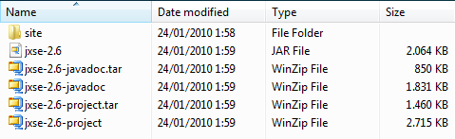
- The /site directory contains an /apidoc directory for online Javadocs.
- The jxse-2.6-javadoc.* files contains zipped version of the Javadoc.
- The jxse-2.6-project.* files contain the source code.
- jxse-2.6.jar is the compiled source code file.

These artifacts can be imported (as is) on the jxse.kenai.com website (using BitKinex for example) in the:

/website/jxse/Downloads/CurrentAndOld/2.6/mvn_artifacts

directory.
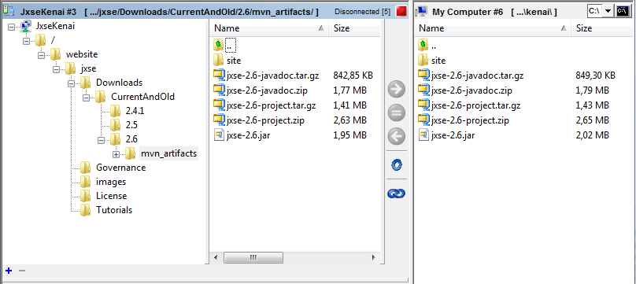
Dependencies
The delivered jxse-2.6.jar has the following dependencies, which should appear in the classpath:

Jar | Description
bouncycastle/bcprov-jdk15-145.jar | Mandatory: used for encryption
h2/h2-1.1.127.jar | Mandatory: used by the H2 implementation of the cache manager (Cm)
jetty/javax.servlet.jar | Mandatory: required by Jetty
jetty/org.mortbay.jetty.jar | Mandatory: required by the HTTP transport
netty/netty-3.1.5.GA.jar | Mandatory: required by the TCP transport
Optional runtime dependencies:
derby/derby-10.5.1.1.jar | Optional: used by the derby based Cm implementation
felix/felix.jar | Optional: used to activate the OSGi framework
junit/junit-4.4.jar | Compile time: unit testing framework
jmock-2.5.1/*.jar | Compile time: mock objects are used in a number of tests

The mandatory Jars are required at runtime. At compile time, the mandatory and optional Jars must be available to perform the build process.

Under The Hood
The purpose of this chapter is to describe what is happening under the hood in JXSE code. One assumes that the reader is familiar with the Java programming language and with the JXTA specification document. The information provided here has been reversed engineered from the code and made available by former contributors to JXTA/JXSE.
The first part of this chapter will describe global code implementation concepts in JXSE. Then, we will cover the well-known JXTA services and specific features such as JXTA bidirectional pipes, JXTA sockets, etc...
Core Implementation Concepts
JXTA Loader
The JXTA loader abstract Java class (implemented via the RefJxtaLoader class) is the fundamental tool that JXSE uses to load Java byte code corresponding to modules or services used within an instance of the application.
This loader is based on a traditional URL Java class loader and offers a couple of extra methods to:
- Load or find the Class class corresponding to the implementation of module via its module specification ID.
- Define modules (i.e. Class Java classes) from their module implementation advertisement.
- Find module implementation advertisements from the corresponding module Class classes or module specification ID.
The Class classes are searched/loaded from either the jxta.jar file in order to start the application, or from the lib jars delivered with the application, or from any other URL location provided to the JXTA loader as a potential source of Java byte code. These URLs may point towards locations on the current device or anywhere on the Internet. This is very useful when one wants to distribute code in one location and have peers load that code remotely to offer services.
In the RefJxtaLoader class, a specific constant called MAX_XFER_TIME controls the maximum amount of time the loader will wait for content to load on the current peer when retrieved from a remote location. It is currently set to 60 seconds.
Just like peer groups, there are several instances of JXTA loaders (one per peer group) and these are organized according to the same hierarchy as the parent-child peer group hierarchy in the application. This is achieved via the initFirst(...) method of the GenericPeerGroup abstract class. An initial and root instance of the RefJxtaLoader class is created as a static attribute of the GenericPeerGroup abstract class when it is loaded. The parent loader of this JXTA loader is the Java class loader used to load the GenericPeerGroup abstract class itself.
Each time one tries to load a class via a JXTA loader, that JXTA loader will first ask its parent loader whether it can load the class (recursively to the root JXTA loader and above) and if not, will try to load it itself. Each instance of JXTA loaders has its own set of URLs. In the current JXSE model, parent loaders prevail on child loaders systematically.
Default Module Implementations
JXSE defines a set of default implementations for well-known modules and services. These are characterized by module specification IDs available from the PeerGroup interface in the net.jxta.platform.Module text file available in the META-INF.services package in the reference implementation source code. In other words, JXSE is using the JAR Service Provider concept.
The following table provides the list of Java classes corresponding to the default implementation of JXTA and JXSE services:
Module/Service | Java class implementation
Resolver service | net.jxta.impl.resolver.ResolverServiceImpl
Discovery service | net.jxta.impl.discovery.DiscoveryServiceImpl
Pipe Service | net.jxta.impl.pipe.PipeServiceImpl
None Membership Service | net.jxta.impl.membership.none.NoneMembershipService
Password Membership Service | net.jxta.impl.membership.passwd.PasswdMembershipService
PSE Membership Service | net.jxta.impl.membership.pse.PSEMembershipService
Rendezvous Service | net.jxta.impl.rendezvous.RendezVousServiceImpl
Peerinfo Service | net.jxta.impl.peer.PeerInfoServiceImpl
Endpoint service | net.jxta.impl.endpoint.EndpointServiceImpl
TCP Message Transport | net.jxta.impl.endpoint.tcp.TcpTransport
HTTP Message Transport | net.jxta.impl.endpoint.servlethttp.ServletHttpTransport
Router Message Transport | net.jxta.impl.endpoint.router.EndpointRouter
TLS Message Transport | net.jxta.impl.endpoint.tls.TlsTransport
JXME Proxy Service | net.jxta.impl.proxy.ProxyService
Relay Message Transport | net.jxta.impl.endpoint.relay.RelayTransport
Always Access Service | net.jxta.impl.access.always.AlwaysAccessService
Simple ACL Access Service | net.jxta.impl.access.simpleACL.SimpleACLAccessService
PSE Access Service | net.jxta.impl.access.pse.PSEAccessService
Cryptobased-ID Message Transport | net.jxta.impl.endpoint.cbjx.CbJxTransport
IP Multicast Message Transport | net.jxta.impl.endpoint.mcast.McastTransport
Content Service | net.jxta.impl.content.ContentServiceImpl
The content of the net.jxta.platform.Module text file is loaded by the default implementation of the JXTA loader to establish links between Java Class objects and well-known module specification IDs.
Each time the Java object instance of a service is required, the corresponding Java Class is extracted from that list and Java reflexion is used to create the object.
Peer Group Global Registry
The peer group global registry is a unique instance of a static class attached to the PeerGroup interface. Its purpose is to manage a list of instances of peer group classes together with their corresponding ID. The purpose of this registry is to make sure that one and only one instance of a peer group exists per ID within an instance of the application.
Typically, this registry used to make sure one and only one instance of the WorldPeerGroup is created within the application.
Peer Group Implementations
The PeerGroup interface is implemented by an abstract class called GenericPeerGroup in JXSE. This class contains the object instances corresponding to the implementation of the well-known JXTA services for the peergroup (Endpoint service, Resolver service, etc...) and of other services provided by the peer group. It also contains the peer's advertisement in this group, together with its module implementation advertisement and some configuration parameters.
A mechanism is also implemented that maintains the number of references to the peer group (for parent-child relationships for example), which uses three methods. It makes sure that a peer group is not stopped before all the references to it have been removed.
The GenericPeerGroup class is extended by several other classes directly or indirectly:
- StdPeerGroup – Extends the GenericPeerGroup class. It contains an instance of the Cm cache manager class. When this module is started, all existing SRDI index local entries for the peer group are deleted. Its services are started. The implementation advertisement of the group and of its discovery service are published locally using the DEFAULT_LIFETIME and default DEFAULT_EXPIRATION constants.
  - Platform – Extends the StdPeerGroup class. This class is the default implementation for the WorldPeerGroup. It contains an essential static method called getDefaultModuleImplAdvertisement() returning a module implementation advertisement containing the module class IDs and the module specification IDS of the standard/reference implementations of JXTA services/modules in JXSE. Contrary to other peer groups, the WorldPeerGroup does not have a parent group.
  - ShadowPeerGroup – Extends the StdPeerGroup class. This class is the default implementation for the NetPeerGroup and retrieves its configuration parameters from its parent peer group (contrary to the Platform peer group).
Other peer groups are created by software engineers by calling one of the newGroup() methods of existing peer group instances. They may or may not provide module implementation advertisements for the creation of new groups. If not, the one from the parent group (i.e. on which the newGroup() method is called) will be used.
Starting the Network
Before one starts the JXTA Network, an instance of the NetworkManager is created. A couple of parameters such as the connection mode (ADHOC, EDGE, RENDEZVOUS, etc...) and eventually a location to persist configuration parameters are provided.
When the JXTA network is started, the following happens:
- If the JXTA network has already been started, nothing happens. The NetPeerGroup is already available.
- Else, if no configuration is available, one is create based on the specified connection mode.
- Then, an instance new of the NetPeerGroup factory class is created.
- The NetPeerGroup factory creates a WorldPeerGroup factory.
- The WorldPeerGroup factory creates a new WorldPeerGroup instance by fetching the name of the class corresponding to its default implementation in JXSE, that is: Platform. This is performed with the help of the JXTA loader.
- The services offered by the WorldPeerGroup are loaded and started.
- The implementation advertisements of the WorldPeerGroup and of its discovery service are published locally.
- A new instance of the NetPeerGroup is created (using the ShadowPeerGroup class) and returned by the NetPeerGroup Factory. WorldPeerGroup is set as the parent peer group.
The services of the NetPeerGroup object will have been started too.
SRDI Manager, Index & Cache Manager
JXSE uses two objects to manage SRDI indexes: SrdiManager and Srdi (since release 2.6, the SRDI class has been renamed into SrdiManager and the SrdiIndex class has been renamed into Srdi). These keep track of advertisement keys (not the whole advertisement) on the local peer, but also keys of advertisements located on other peers, depending on their role. These two objects work in combination with a third object, the CacheManager storing the advertisements themselves.
Typically, an EDGE peer will only exchange SRDI information with the RENDEZVOUS it is connected to. RENDEZVOUS exchange random extracts of SRDI information they possess with other RENDEZVOUS they are connected to. These are called replica peers.
The SrdiManager class implements the RendezvousListener interface to process messages exchanged between rendezvous or peers. It also creates a SrdiManagerPeriodicPushTask object which pushes SRDI entries at a regular rate. Srdi objects are created by peergroup services: discovery service, the RouteResolver class and the PipeResolver class which we will cover later.
- DiscoveryService – When this service is started, its behavior depends of the connection mode.
If it is a rendezvous, it will not track deltas (i.e. modifications in the local manager). A SRDI is created together with a corresponding SRDI manager. The discovery service registers as a SRDI messages handler in the resolver service.
If we are an edge and if we are connected to a rendezvous, deltas are tracked. No Srdi object is created, but a SrdiManager is. It is a attached SrdiManagerPeriodicPushTask which is started to push delta entries keys to the connected rendezvous.
- RouteResolver – The route resolver maintains route advertisement SRDI entries in a Srdi object. A corresponding SrdiManager is created too. However, the router resolver does not push its entries automatically. It is the corresponding EndpointRouter that does via the setRoute() method when new routes are available.
- PipeResolver – The pipe resolver create a SRDI class to store input pipe information. If this peergroup is an edge deltas are pushed to the connected rendezvous. If it is a rendezvous, entries are replicates to replica peers.
SRDI Manager
The SrdiManager class offers several methods:
- replicateEntries() - This method takes a SRDI message in parameter, extracts its entries, selects a random peer from the local peer view (called a replica peer) for each entry and pushes a new SRDI message based on the primary key contained in the parameter SRDI message to the selected peer using the pushSrdi() method.
- pushSrdi() - This method creates a resolver SRDI message, invokes the resolver service of the peergroup and calls the sendSrdi() method.
- forwardSrdi() - These methods forward a query using the resolver service of the peergroup.
- forwardSrdiMessage() - This method builds a Srdi message from parameter elements and sends it to a target peer.
- RendezvousEvent() - This method captures Rendezvous events. If a rendezvous disconnects or a rendezvous connection failed, the local SRDI entries are republished to other peers.
REM: A Srdi manager object will only replicate entries if its peerview contains at least 2 entries (cf. RPV_REPLICATION_THRESHOLD).
SRDI
The Srdi object implements the runnable interface. This is the object creating SRDI entries on the local peer. Several methods are available to manipulate entries: add(), getRecord(), getIndexMap(), clear(), etc... Entries are published with a lifetime. The run() method periodically calls the garbageCollect() method to remove expired entries. The stop() method stops the garbage collection thread and closes all opened files.
Cache Manager
Peers need to store advertisements locally on peers to operate on the JXTA network. This is performed with the help of the CacheManager class. CacheManager object instances are created by peergroup object instances when these are initialized.
Similarly to the Srdi class, the CacheManager object creates files entries, unless the in-memory implementation is selected. The object offers several methods to manage records and implements a garbage collection system too. The cache manager 'tracks deltas', that is, changes in the local published advertisements.
Well-known Services
The following pages describe what is happening in the implementation of the JXTA services in JXSE. The author is assuming that the reader is familiar with these services. One should keep in mind that services are subtypes of modules and that every instance of a service is a Java object attached to a peergroup.
With a twist...
The service object instances returned by the GenericPeerGroup class are not direct instances of the Class objects defined by the JAR Service provider, but rather interfaces to them. GenericPeerGroup calls the getInterface() method on the instance of the well-known service it possesses.
For example, the GenericPeerGroup.getEndpointService() does not return an instance of EndpointServiceImpl, but an instance of EndpointServiceInterface, since a call to EndpointServiceImpl.getInterface() will return such an object.
The returned 'interface' also implements the EndpointService interface, together with corresponding methods, in a slightly different way than the EndpointServiceImpl object. It also the calls methods on the 'real thing' EndpointServiceImpl object it knows via its constructor.
The consequence is that software engineers must not only take a look at Java class implementation of the well-known services in the net.jxta.platform.Module text file of the META-INF.services package to understand how JXSE implements JXTA. They should first take a look at the corresponding 'interface' objects returned by the getInterface() methods of these classes, since all implementations of peergroups in JXSE rely on the GenericPeerGroup class.
Before we start describing the implementation of the endpoint service (and subsequently other well-known services), we will first describe several implementation concepts of the transportation layer.
Transportation Layer
The following pages describe fundamental concept of the transporation layer implementation in JXSE.
Message Transports
The message transports of a peer are responsible for sending and receiving message to and from other peers over the JXTA network, using whatever protocol they wish. There are three types of message transports: message receivers, message senders and messages propagators (for propagated messages like multicasting) in JXSE.
Several classes implement the message sender, receiver and propagator protocols:
Implementing Classes | Message Sender | Message Receiver | Message Propagator
TcpTransport | X | X
McastTransport |  |  | X
HttpMessageReceiver |  | X
HttpMessageSender | X
TlsTransport | X | X
RelayClient |  | X
RelayServer | X
EndpointRouter | X | X
CbJxTransport | X | X
- TcpTransport - This class implements the TCP Message Transport.
- McastTransport - This class implements the TCP Message Transport.
- HttpMessageReceiver - Simple Message Receiver for server side..
- HttpMessageSender - This class implements the TCP Message Transport.
- TlsTransport - Implementation which uses TLS sockets..
- RelayClient - RelayClient manages the relationship with the RelayServer(s).
- RelayServer - Relay server that maintains outgoing message queues, leases, etc.
- EndpointRouter - This class implements the TCP Message Transport.
- CbJxTransport - Message transport implementation which which provides message verification by examining message signatures (this has not been activated in the code yet).
Message transports are registered in each endpoint service object instances according to type of communication layer which is enabled (or not) by the configuration.
Typically, messengers are retrieved from message transports in order to send messages. For example, calling getMessenger() on TcpTransport will return either a LoopbackMessenger if the destination is one of the public addresses of the transport or a new TcpMessenger otherwise. We will cover the Messenger interface and this topic further.
Message Sender
The MessageSender interface extends the MessageTransport interface. It offers a getMessenger() method which returns a Messenger for a given Endpoint address. This messenger can later be used to send messages.
Each message sender contains the endpoint address where replies to sent messages should be sent. A MessageSender can be connection oriented (like TCP/IP), meaning that series of messages can be transported efficiently to the destination. It can also allow routing, meaning that it can be used as a intermediary step (hop) to forward messages to peers who are not directly reachable via this transport.
Message Receiver
The MessageReceiver interface extends the MessageTransport interface. It receives messages from the network. It also defines one method called getPublicAddresses() which returns the list of public address from which it is reachable.
Message Propagator
The MessagePropagator interface extends the MessageTransport interface. It defines a getPublicAddress() method which returns the endpoint address of the sender, together with a propagate() message to send/propagate messages to multiple peers.
Messengers
Messengers are implemented to send messages to a destination. A messenger contains methods to retrieve the endpoint destination address and the maximum message size it is capable of handling. Wherever applicable, this interface also defines a getChannelMessenger() method to return another messenger to the same destination if available. We will cover channel messengers later.
Several sending methods are defined in the Messenger interface. Some will throw an IOException is the message is malformed or if the Messenger is not usable anymore. Some will invoke an OutgoingMessageEventListener when provided.
Software engineers can also monitor the status of a sent message by calling the getMessageProperty(Messenger.class) method on it. This will return an OutgoingMessageEvent object which can be compared to OutgoingMessageEvent.SUCCESS or OutgoingMessageEvent.OVERFLOW (REM: It is not because a message has been successfully sent from a peer that guarantees that it will necessarily reach its destination).
Several statuses are defined for messengers:
Status | Description
UNRESOLVED | No message was ever submitted for sending. No connection has ever been attempted.
RESOLVING | Initial connection is being attempted. No message is pending.
CONNECTED | Currently connected. No message is pending (being sent implies pending).
DISCONNECTED | Currently not connected. No message is pending.
RESOLPENDING | Initial connection is being attempted. Messages are pending.
RESOLSATURATED | Initial connection is being attempted. Messages are pending. New messages may not be submitted at this time.
SENDING | Currently connected and sending messages.
SENDINGSATURATED | Currently sending messages. New messages may not be submitted at this time.
RECONNECTING | Currently trying to re-establish connection. Messages are pending.
RECONSATURATED | Currently trying to re-establish connection. New messages may not be submitted at this time.
RESOLCLOSING | Attempting initial connection. Close has been requested. Messages are pending. New messages may no longer be submitted.
CLOSING | Currently sending messages. Close has been requested. New messages may no longer be submitted.
RECONCLOSING | Trying to re-establish connection. Close has been requested. Messages are pending. New messages may no longer be submitted.
UNRESOLVING | Failed to establish initial connection. Pending messages are being rejected. New messages may no longer be submitted.
BREAKING | Failed to re-establish connection. Pending messages are being rejected. New messages may no longer be submitted.
DISCONNECTING | Breaking established connection for expedite closure. Pending messages are being rejected. New messages may no longer be submitted.
UNRESOLVABLE | Failed to establish initial connection. New messages may no longer be submitted. State will never change again.
BROKEN | Failed to re-establish connection. New messages may no longer be submitted. State will never change again.
CLOSED | Closed as requested. All pending messages could be sent. New messages may no longer be submitted. State will never change again.
Messenger Implementations
Class (with inheritance level) | Description
AbstractMessenger | Base abstract class for implementation of all messengers.
- ChannelMessenger | Abstract class messenger for sub-destinations of a destination, like a service for example.
- - AsyncChannelMessenger | Abstract class messenger to provide asynchronous message sending via queuing.
- - - ThreadedMessengerChannel | Private class of the ThreadedMessenger returned when its getChannelMessenger(...) method is called.
- - BlockingMessengerChannel | Private class of the BlockingMessenger returned when its getChannelMessenger(...) method is called.
- BlockingMessenger | Abstract class for 'real' transportation messengers.
- - RelayMessenger | Protected static class of RelayServerClient returned when getMessenger(...) is called.
- - RouterMessenger | Class implementation for destinations which are logical peers.
- - HttpClientMessenger | Simple messenger that simply posts a message to a URL.
- - HttpServletMessenger | Simple messenger that waits for a message to give back to the requesting client
- - TcpMessenger | Implements a messenger which sends messages via raw TCP sockets
- - TlsMessenger | This class implements sending messages through a TLS connection
- - LoopbackMessenger | Messenger delivering local messages when the source peer is identical to the destination peer.
- ThreadedMessenger | Abstract class shared by multiple channels to automatically distribute the available bandwidth among the channels.
- - CanonicalMessenger | Private classes of the Endpoint service implementation returned when the getCanonicalMessenger(...) method is invoked.
The table above describes the classes implementing the Messenger interface. There are three types of messengers serving different purposes; blocking messengers, canonical messengers and channel messengers:
- BlockingMessenger – These messengers are physically sending messages to others peers, with the exception of the RouterMessenger which searches for routes to other peers (if necessary) before sending them via other blocking messengers.
- CanonicalMessenger – These are non-blocking messengers storing messages to a destination peer in a queue. They are linked to at most one and only one blocking messenger at any given time to transmit messages to other peers. They remain open as long as the destination is reachable, even if the underlying messenger may change.
- ChannelMessenger – These messengers are used to send message to a specific destination on a destination peer (for example the rendezvous service, the pipe service, etc...). They are attached to the canonical messenger for the destination peer.
Most often, channel messengers are used by the application as intermediaries to send messages, but sometimes, they are skipped when a direct messenger is used. Typically, a direct messenger is a messenger capable of direct connection and communication to another peer (for example, through TCP).

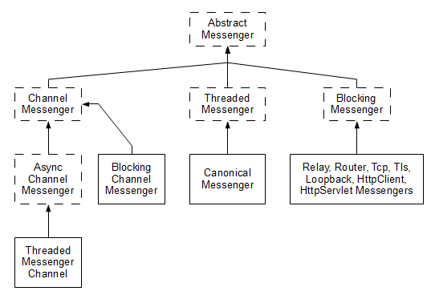
The above diagram show the inheritance structure of messenger classes.
Endpoint Service
The EndpointServiceImpl class implements the JXTA discovery service via the EndpointService and the MessengerEventListener interface. Each instance its own collection of MessageTransports. Each transport registers itself in the Endpoint service when created.
Using Message Transports
- The Endpoint service implements the getMessageTransport() method which is typically called with the “jxta” or “tcp” parameter by the well-known services. Using the “jxta” parameter will return the instance of the EndpointRouter sending messenger, upon which the getMessenger() method can be called.
Depending on the provided parameters, the returned object can be a LoopBackmessenger if the target peer is this peer or a RouterMessenger:
- LoopBackmessenger – Each time a message is sent with this messenger, it creates a runnable which will invoke the processIncomingMessage() of the current endpoint service.
- RouterMessenger – These messenger are for virtual peer destinations. A virtual peer is a JXTA address which is based upon a peer ID rather than on a physical network address. When created, the RouterMessenger will invoke the getGatewayAddress() method from its EndpointRouter, which will convert the virtual address:
  - Either into a direct non-virtual endpoint address if the peer can be reached directly
  - Or into the address of the first peer along a route leading to the destination peer
REM: If no route is available, the peer will use the routing protocol to try to fetch one route from other peers in the peergroup for 30 seconds.
  - If the conversion is unsuccessful, the creation of the RouterMessenger is aborted by throwing an IOException.
When a message is sent, a Messenger for the converted address is retrieved and used to send the message. This messenger is typically directly 'connected/resolved' to the destination peer.
Well-known services can also call the getMessageTransport() method to retrieve all available message transports on the endpoint service and loop them to retrieve a Messenger.
Retrieving Messengers
The 'interface' version of the endpoint service (cf. EndpointServiceInterface) implements the getMessenger() method(s) in a different way than the default implementation:
- getMessenger() will try to retrieve an immediate messenger through the getMessengerImmediate() method:
  - This method will check whether a channel messenger already exists for the provided endpoint address and return it if it is in a USABLE state.
- Else, the EndpointServiceInterface calls the getCanonicalMessenger() method of the EndpointServiceImpl, which loops through its map of messenger to check whether a usable one is available. Any unusable canonical messenger is deleted.
    - If none is available, we check whether a message sender for the endpoint address type (TCP, HTTP, virtual peer address...) is available within the endpoint service. If yes, a new canonical messenger instance is created and returned.
    - Else, if a parent peergroup is available, we try to retrieve the a canonical messenger from it.
    - Otherwise, null is returned.
- If no canonical messenger can be found (i.e. the endpoint address type is not supported by the endpoint service), getMessengerImmediate() returns null.
  - Else, we retrieve a channel messenger from the canonical messenger. We double-check that no channel messenger has been created since we first checked. If yes, we return it. Else, we register the new channel messenger and return it.
- If no channel messenger is returned, the getMessenger() returns null too.
- Else, we explicity request the messenger to resolve (i.e., to try to 'connect' to the target peer) within one minute.
- If successful, we return the messenger, else we return null.
The returned messenger (if available) can be used to send messages. Several features retrieve messengers from the endpoint service (for example: JxtaSocket, JxtaBidiPipe, output pipes...).
Incoming Messages
When a message is arriving at an instance of an endpoint service, the following happens:
- If the source peer (i.e., sender) is this peer, then the message is a loop-back. It is discarded.
- If the source address or the destination is null, the message is discarded too.
- If the destination service name is null or of length 0, the message is discarded too.
- The message is passed through any existing filter and may be discarted (i.e., filtered out).
- We try to retrieve a listener for the corresponding service name and parameter.
- If none is available, the message is discarded.
- Else, the listener is called.
Diagrams
The endpoint service is complex. Some diagrams have been provided in Appendix A to facilitate the understanding of this service.
Messenger Methods Callers
The following table indicates which parts of the code calls which messenger method at the EndpointService level:
Method | Caller
GetMessenger() | JxtaSocket via LightweightOuputPipes
GetMessenger() | JxtaBibiPipe via LightweightOuputPipes
GetMessenger() | PeerConnection - To remote peers
GetMessenger() | AdhocRdvService - For message propagation
GetMessenger() | BlockingWireOutputPipe - To get usable messengers
GetMessenger() | NonBlockingOutputPipe - For asynchronous sending
GetMessenger() | RelayServer – For lease requests
GetMessengerImmediate() | Destinations – To get wisdom about routes
GetMessengerImmediate() | ResolverService – To send messages
GetMessengerImmediate() | RendezvousService – To propagate messages, send disconnects, monitor connections with remote peers...
GetMessengerImmediate() | PeerView & PeerView Elements – To send peerview messages
Resolver Service
The ResolverServiceImpl class implements the JXTA resolver service using the ResolverService interface. Amongst other things, this object contains a list of query handlers and SRDI handlers, together with a reference to the peergroup's Endpoint service and Membership service.
During the initialization of the service, a unique ID string is created as a base to create unique handler names. Then, an (incoming) query listener, a query response listener and a SRDI listener are created with respectively the DemuxQuery, DemuxResponse and DemuxSrdi private classes. These listeners are registered in the Endpoint service.
- Typically, DemuxQuery implements the EndpointListener interface. Each time a message arrives, the 'query' part is extracted and processed. If a matching query handler exists (i.e., has been registered in the resolver service), the query is transmitted to it.
If no query handler can be found and if the current peer is acting as a Rendezvous for its peer group, the query is propagated to other known rendezvous who may have a handler for it (or who may forward it themselves). A loop and TTL (time to live) control system is implemented to check sent messages. The query is also forwarded to all the peers of the peergroup reachable on the local network (using multicasting or broadcasting).
If no query handler can be found and if the current peer is not acting as a Rendezvous for its peer group, the query is propagated to all other peers using all available message transports.
- The DemuxResponse class implements the EndpointListener interface too. When a message arrives, the 'query response' part is extracted and processed.
If a matching query handler exists (i.e., has been registered in the resolver service), the query response is transmitted to it. Else, the message is ignored.
- The DemuxSrdi class also implements the EndpointListener interface. When the message arrives, its content is extracted and processed.
If a corresponding Srdi handler is available, the message content is transmitted to it. Else, it is ignored.
When a query is sent to a destination peer, a route back to the sending peer may be included if this is not available in the message. This may facilitate the work of the destination peer to send back answers, since often, it may not possess that route information.
If a destination peer is specified, a messenger to the destination is retrieved from the Endpoint service and the message is sent.
If no destination peer is specified and the current peer is acting as a Rendezvous for its peer group, the query is sent to other known rendezvous. The query is also forwarded to all the peers of the peergroup reachable on the local network (using multicasting or broadcasting). If the current peer is not acting as a Rendezvous, the query is sent to all other peers using all available message transports.
A similar process is used to send query responses. If a route to the issuing peer is available, it will be used as a hint to send the response back.
All Srdi message sent by the resolver service are zipped before sending.
When the resolver service is stopped, all registered listeners in the Endpoint service are removed.
Discovery Service
The DiscoveryServiceImpl class implements the JXTA discovery service via the DiscoveryService interface (amongst others). This object contains a list of discovery listeners, together with a reference to the peergroup's Resolver service, Rendezvous service and Membership service. It also contains a local instance of a srdi and a srdiIndex object.
During initialization, the DiscoveryServiceImpl object registers itself as a query listener in the resolver service and in the rendezvous service.
When advertisements are retrieved remotely:
- A unique query ID is created based on an Java atomic integer.
- Then, a discovery query is created using provided parameters.
- If a discovery listener is provided, it is registered within the discovery service together with the query ID.
- A resolver query message is created and the discovery query is 'embedded' into it, together with the current peer ID (i.e., source/sender).
- If a target peer is specified or no SRDI index is available, the query is forwarded using the sendQuery() method of the resolver service.
- Else the discovery service will do its best to select proper target peer IDs from the SRDI entries, using attribute and value parameters when available. If such entries are available the forwardQuery() method of the Srdi object will be used. Else, the discovery service will revert to the sendQuery() method of the resolver service. It is not because because we do not know proper target peers that other peers don't.
When queries are received by target peers who can answer them, the respond(...) method is called, which crafts a query response and sends it to the source peer. The private rawSearch() method can be used to search for local advertisements (i.e., in the cache manager) to answer queries.
The discovery service implements other methods to publish advertisements locally or remotely, together with publication method. In the latter case, remote publications are performed using the same mechanisms and methods used to answer queries.
Processing SRDI Messages
The discovery service implements the SrdiHandler interface and processes SRDI messages via a couple of methods:
- processSrdi() - This method takes in a ResolverSrdiMsg, extracts its SRDI entries, add them to the SRDI index and replicates the entries to other RDVs.
- pushSrdi() - This method is used to push entries from this peer to other peers and ensure replication of srdi entries.
The discovery service registers itself as a SrdiHandler in the resolver service when the peer is a RENDEZVOUS or becomes one.
Switching between RENDEZVOUS/EDGE
The discovery service uses two methods to switch its behavior between EDGE and RENDEZVOUS:
- beEdge() - if a RENDEZVOUS, track deltas in the cache manager only and unregister this discovery service as a SrdiHandler. Recreates a Srdi instance.
- beRendezVous() - Switches the RDV boolean flag and stops tracking deltas. Recreates a Srdi instance and registers as a SrdiHandler in the resolver service.
Rendezvous Service
RendezVous Service Implementation
The RendezVousServiceImpl final class implements the JXTA rendezvous service via the RendezVousService interface. This class contains (amongst others) references to the peergroup's endpoint service and a list of rendezvous listeners. When initialized, information such as the auto-rendezvous status and check interval is retrieved from the configuration.
If this peergroup is the WorldPeergroup, then the rendezvous service adopts an AD_HOC rendezvous configuration (which we will describe later). Else, according to the connection mode of the peer (AD_HOC, EDGE or RENDEZ_VOUS), an instance of the AdhocPeerRdvService class, the EdgePeerRdvService class or the RdvPeerRdvService class is created. This object instance is referred to as the provider. In other words, the rendezvous service behaves in different ways according to the connection mode.
All providers extend the RendezVousServiceProvider abstract class (directly or indirectly), which implements the EndpointListener interface. When started, it registers itself in the endpoint service of the peergroup for rendezvous propagate messages and unregisters when it is stopped. When it receives a message , a check on the TTL (time to live) and on possible loop (by checking whether this peer ID is already in the propagation list) is made to discard it if needed. Else, if we have a local listener for the message, it is transferred to it.
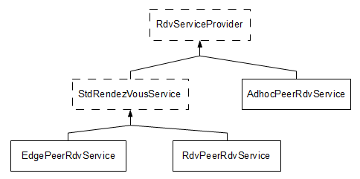
The RendezVousServiceProvider class also provides abstract methods to challenge rendezvous (i.e., check that leases are still alive within a given delay), to connect to other rendezvous, to disconnect from rendezvous, to retrieved the list of connected peers, to propagate messages, to indicate whether the peer is connected to a rendezvous, to walk messages to other rendezvous peers, to repropagate messages and to propagate messages in the peergroup. It also defines a set of methods to manage propagation headers in rendezvous propagate messages (add, update, remove, extract, etc...).
A RdvWatchdogTask private class is also defined to manage the auto-rendezvous status. If it is set and if the current peergroup is not the WorldPeerGroup, a periodic task is created to check whether the peer should become a rendezvous for its peergroup:
- If the peer is not a rendezvous and if it did not manage to connect to a rendezvous, it becomes one.
- If the peer is a rendezvous, we check whether we can demote ourselves:
  - If the peer view contains more rendezvous than the DEMOTION_MIN_PEERVIEW_COUNT limit (currently hardcoded at 5) and if no peers are connected to this rendezvous, it stops behaving as a rendezvous.
  - Else if there are less than DEMOTION_MIN_CLIENT_COUNT (currently hard-coded at 3) clients connected to the rendezvous, there is 1 chance out of 20 that it will stop behaving as a rendezvous (cf. the DEMOTION_FACTOR set at 0.05).
If a demotion or a promotion happens, the Rendezvous service changes of RendezVousServiceProvider instance, by creating a new ones.
Standard RendezVous Service
The stdRendezVousService abstract class extends the RendezVousServiceProvider class. It defines a timer to schedule tasks. When started, it registers a StdRdvProtocolListener in the endpoint service and unregisters it when stopped.
This class implements some of the abstract method defined in the RendezVousServiceProvider class. It also defines some abstract methods to retrieve peer connections (described next) and offers a method to send a message to each connection. It also provides a method to send disconnect requests to remote peers.
When a message from another peer arrives, this class checks whether with have a connection with it and if not, it sends a 'disconnect' to it (unless we are not an edge peer ourselves). In any case, the message is transmitted to RendezVousServiceProvider super class too.
PeerConnection
The PeerConnection is an abstract class implementing the OutgoingMessageEventListener and is used to manage leases between RENDEZVOUS and EDGEs, and connections between rendezvous via the RdvConnection and ClientConnection classes. It maintains a boolean indicating whether one believes that we are still connected to the remote peer or not. It also keep tracks of the amount of milliseconds we believe the connection will timeout unless when it is renewed.
The PeerConnection class also implements a getCachedMessenger() method to retrieve a Messenger for communication to the remote peer. A sendMessage() is method is also implemented to send messages with the Messenger. If a message fails to be sent, the connection status will be set to false (unless this is caused by a queue overflow).
RendezVous Service Providers
For each type of provider:
- AdhocPeerRdvService – Extends the RendezVousServiceProvider. Ad hoc peers do not connect to rendezvous peers, but their rendezvous service will nevertheless forward and propagate rendezvous messages when received from other peers.
- EdgePeerRdvService – The edge peer rendezvous service extends the StdRendezVousService (which extends the RendezVousServiceProvider abstract class) and manages connections to rendezvous from an EDGE perspective. The object also contains an instance of a SeedingManager and a list of current connections with rendezvous.
An edge peer tries to connect to one and only one rendezvous (cf. MAX_RDV_CONNECTIONS) and will check its connection every 15 seconds (cf. MONITOR_INTERVAL). The lease margin is set to 5 minutes and the TTL is set to 200 by default. These can be modified through configuration.
A MonitorTask private class is implemented to managed connections to rendezvous. It tries to renew an existing lease before expiration if necessary and tries to create new ones using seeds when necessary.
- RdvPeerRdvService – The rendezvous peer rendezvous service also extends the StdRendezVousService, and manages leases with EDGE and RENDEZVOUS peers. When started, existing configuration is retrieved or default values are used if not available. The lease margin is set to 5 minutes and the TTL is set to 200 by default. The default maximum number of connections with clients is set to 200 (cf. DEFAULT_MAX_CLIENTS).
A StdRdvRdvProtocolListener private class handles lease requests and disconnect requests from edge peers. The RdvPeerRdvService also refersto a ClientConnection class in order to handle connections with other peers and to a PeerView class which listens for peerview messages from the Endpoint address.
When the service is started it creates a garbage collection recurrent task checking the status of 'client' connections and remove leases when necessary.
Pipe Service
The PipeServiceImpl class implements the JXTA pipe service via the PipeService interface. During initialization, it creates a PipeResolver class for the resolution of unicast pipes and a WirePipeImpl class for the resolution of propagate pipes.
The PipeResolver class maintains a map of (pipe ID, input pipe) pairs and a map of (pipe ID, set of output pipe listeners) pairs. When instantiated for a given peer group, the object registers as a listener in the corresponding resolver service. New instances of the Srdi and SrdiIndex objects are created. The PipeResolver instance also registers as a SRDI handler in the resolver service.
When a query containing a pipe resolver message arrives and the destination is any peer or this peer, the pipe sends a response mentioning whether a matching input pipe is available or not (i.e., whether the resolution is successful). Else, if the peer is a RDV, the SRDI objects are invoked to forward the message to other appropriate peers (maximum 20). If such peers IDs are not available from the SRDI or if the peer is an edge, we send a response to the issuer using the resolver service.
When a pipe resolver message response arrives, the responding peers advertisement is extracted and published locally using default expiration and default lifetime. If the response is negative, any matching entry in the local SRDI is removed, else it is created or renewed with an expiration of 10 minutes. The output pipe listener (if any is available) is notified either with a resolution event or a NACK (no acknowledgment) event.
The PipeResolver class is capable of receiving SRDI messages, and therefore processes the content (i.e., save it in the local SRDI) to facilitate the resolution of pipes. When such messages are received, they are propagated to other peers unless the information is related to propagated peers.
The WirePipeImpl class is implemented for propagated pipes at a peergroup level. It implements the EndpointListener interface and registers itself in the endpoint service of the peergroup. It also maintains a set of unique WirePipe class instances per pipe ID when InputPipeImpl objects are created through it. When messages arrive, the WirePipe instance corresponding to the Pipe ID is retrieved, and if it exists, the message is transmitted to it. When a WirePipeImpl object is stopped, existing wire pipes are closed one by one and the object removes itself from endpoint incoming listeners' list.
Contrary to the PipeResolver class, the WirePipeImpl class does not implement SRDI objects.
When an input pipe is created via a call to createInputPipe() in the PipeServiceImpl class, one of the following object is returned according to the pipe type:
- UnicastType – An InputPipeImpl is created by providing the PipeResolver class instance. If a pipe message listener is provided, a synchronized queue of size 100 is created within the InputPipeImpl object. Then, the new InputPipeImpl is registered in the PipeResolver.
- UnicastSecureType – A SecureInputPipeImpl (which extends InputPipeImpl) class instance is created. The constructor calls the super constructor.
- PropagateType – An InputPipeImpl is created using the WirePipeImpl class.
When an output pipe is created via a call to createOutputPipe() in the PipeServiceImpl class:
If the number of peers who can (potentially) resolve the pipe is 1, a new output pipe is created via the BlockingWireOutputPipe object. Its constructor calls an essential private method called checkMessenger(). This method checks whether a Messenger to the remote peer is available and whether it is usable. If not, it tries to retrieve a direct one from the endpoint service or a regular messenger if it is not successful.
Else, the output pipe is created by calling the wirePipe.createOutputPipe() method which returns a NonBlockingWireOutputPipe. This pipe can handle multiple destination peers.
When sending a message with the BlockingWireOutputPipe object, one checks (twice if necessary) whether a messenger is available and tries to send it using the sendMessageB() method. If unsuccessful, an IOException is thrown.
When sending a message with the NonBlockingWireOutputPipe object, the wirePipe.sendMessage() method is called:
- PropagateType – If this peer belongs to the list of target peers, the local input pipe listeners are called. If the list of peers is empty (i.e. the message is to be sent to every peer) and if the peer is a rendezvous, or if the list of target peer is not empty, the message is propagated via the rendezvous service. Else, it is walked through the rendezvous service.
- UnicastType and UnicastSecureType – An output pipe listener is created and registered in the corresponding list. An input pipe resolution query is sent to the resolvable peer (or any peer if no peer is specified). We also check for local listener.
When the service is stopped, the WirePipeImpl class and the PipeResolver class are stopped too. All listener lists are cleared.
Simple Pipe Communication
Simple pipe communication implies the creation of an output pipe on an output peer and the creation of an input on an input peer. For the sake of simplicity, we will consider that both peers are different, although communication could happen on the same peer. As a reminder, once an output pipe is created, it tries to resolve to an input pipe.
PipeService – Create Input Pipe
When an input pipe is created (regardless of its type), an input pipe listener may be provided that is notified of new messages. The PipeService creates the proper object InputPipe which registers itself in the PipeService's PipeResolver object. The resolver handles pipe resolution queries coming from output pipe peers and will answer those addressed specifically to the registered input pipe. The resolver also registers the input pipe as an incoming message listener in the endpoint service.
Later, when a message arrives for the input pipe peer, these are either stored on a queue for later polling or directly sent to the corresponding listener if such is available. REM: if the queue is full, some messages may be lost/discarded without notice.
PipeService – Create Ouput Pipe
When an output pipe is created and depending on the selected creation method, the pipe service will attempt the resolution with an input pipe itself before returning the output pipe object, or it will 'remember' the provided output pipe listener and send a pipe resolution query.
OutputPipe Send
The output pipe implementation for simple pipe communication is the BlockingWireOuputPipe object. When sending a message:
- The destination messenger is checked. If it is available and USABLE, the check stops successfully here.
- Else, we try to retrieve a directed messenger from the endpoint service. If none is available or if one is available, but in a terminal state, we try to retrieve a regular messenger.
- If we can't retrieve a messenger or if the retrieved messenger is in a terminal state, an IOException is thrown.
- Otherwise, the sendMessageB() method of the Messenger is called.
Bidirectional Pipe Communication
Bidirectional pipe connection requires the creation of a JxtaServerPipe on a server peer and to retrieve a JxtaBidiPipe using the accept method. The sending peer creates a JxtaBidiPipe using the same pipe advertisement as the server pipe to send messages.
New JxtaServerPipe
When the JxtaServerPipe is created, it creates an input pipe from the pipe service and behaves as a listener for it. When a new pipe connect message arrives, it used to create a JxtaServerPipe which is registered in a connection queue. During this process, a Messenger is retrieved from the endpoint service and used as a parameter to a protected constructor of the JxtaBidiPipe.
When the accept() method is called, the JxtaServerPipe polls the connection queue to retrieve an instance of a JxtaBidiPipe connection.
New JxtaBibiPipe
When a JxtaBidiPipe is created with one of its public constructor, it calls it connect() method which creates an open message (i.e., connection request) and an output pipe. Then, it waits for its resolution and notify listeners, if any.
Bidirectional pipes can be made reliable and use a “sliding window” mechanism (similar to TCP/IP) where received messages are acknowledged and re-ordered for proper delivery. These can be resent if necessary.
JxtaSocket & JxtaSocketServer
In order to establish a JxtaSocket communication, a 'server' peer will create a JxtaSocketServer and 'accept' a socket from it. Another 'socket' peer will create a JxtaSocket, using the same pipe advertisement as the 'server' peer.
When a JxtaSocket is created:
- The default timeout for connection and closing is set a 60 seconds. The retry timeout is also set at 60 seconds.
- A local input pipe is created and a connection is attempted. If the socket is to be reliable, a pair of ReliableInputStream and ReliableOutputStream are created, else a pair of JxtaSocketInputStream and JxtaSocketOutputStreams are created.
JxtaMulticastSocket
The JxtaMulticastSocket class replicates the typical UDP multicasting functionality over “groups” (i.e., reserved IP addresses), over peergroups using output pipes (unicast for communication to a specific peer, or propagate type).
However, JxtaMulticastSocket does not rely on UDP to communicate with other peers.
PeerInfo Service
We will not describe this service here as documents are available from: https://jxse-metering.dev.java.net/.
Membership and Access Services
These are the PSE Membership Service, the Non Membership Service, the Always Access Service, the Password Membership Service, the PSE AccessService and the Simple ACL Access Service. Unfortunately, we will not describe these in this document, since major revision and improvement of the code is expected in future releases of JXSE.
About The Future
This section contains comments and considerations about the future of JXSE.
The JXSE Architecture
OSGi, Modules, Service & JxtaLoader
Currently, the RefJxtaLoader extends the JxtaLoader. And, the JxtaLoader extends the URLClassLoader in the API code, which restricts other implementations of the JXTA service loader concept. Using .jar files as the base method to load services on a Java/JXTA platform has several drawbacks:
- There is no way to indicate dependencies between .jar files.
- There is no versioning in .jar files. Hence, it is not possible load different versions simultaneously. Moreover, it is not possible to indicate which classes should be loaded when several versions are available and required by classes in other .jars.
- .jar files can contain conflicting names. Thus loading classes from classpath entries can cause unexpected and hard to solve conflicts.
This makes modular loading (of services) very hard to achieve on a large scale. Currently, JXSE dodges many of these issues, because all required modules and services are located in the delivered jxta.jar and few members of the community have implemented their own modules.
Suggestions
The OSGi framework solves all the .jar drawbacks. Therefore, it is in the interest of the community to pursue effort towards integration with OSGi. Early investigation indicate that re-implementing core JXTA service on top of the OSGi framework would probably be overkill, but nudging developers to implement JXTA services as OSGi services/bundles might be wise.
For example, an OSGi peer factory service could be implemented, from which peer objects could be used to create/join peer groups, on which OSGi/JXTA services could be loaded. These could be implemented via a delivered API interface or abstract class. Apache Felix iPOJO may help facilitating coding and development.
Another benefit of OSGi is that offers simple functionality to check which other services have been loaded, and makes them easily accessible.
The RefJxtaLoader should progressively be deprecated and replaced by this alternative load mechanism. Corresponding peer group methods should be implemented.
Multiple peers in same JVM & Test Driven Implementation
One of the weaknesses of the JXSE implementation of JXTA protocols is that it does not allow the creation of multiple peers in the same JVM. This makes automatic testing of peer behavior nearly impossible to accomplish. There is a possibility of working around this issue by using separate class loaders, but this is cumbersome and very complex to achieve. Another solution, implemented by some, is to use mock classes.
The culprit is, amongst others, the peer group global registry (see PeerGroup.GlobalRegistry) which forces the creation of one and only one instance of a peergroup object per PeerGroupIDs. Other singletons may obstruct the creation of several peers within the same JVM.
Multiple peers in the same JVM has been requested by the community for quite some time, but requires some deeps modifications in core code. Its implementation would significantly facilitate a test driven continuous implementation process of JXSE.
Simplifying The Transportation Layer
The implementation of the Endpoint service and underlying transportation layer could be significantly simplified. Channel messengers are not really necessary and could be replaced by canonical messengers only. Direct messengers have been deactivated and should be removed from the code.
Earlier leaders of the community have considered getting rid of blocking messengers, then asynchronous messengers and at last of channel messengers in the past. JXSE implements too many classes to achieve what has to be achieved. This consumes unnecessary resources (memory and processing time).
A lot of code has been written around 'hint processing', but these are only used in the Endpoint router and by immediate messengers (which have been deactivated). Many methods take in unnecessary parameters and propagate content to other methods. The code could be simplified.
Right now, EndpointService object instances do not share there connections to other peers (TCP, http, multicasting, etc...) between themselves. This is a unnecessary resource consumption. Since these are purely 'physical' means to exchange messages between peers, one could centralize them in a separate object to which peergroups would refer to to send messages and/or register listeners. In other words, we could have unique instances of MessageTransport objects.
Authentication & Security
Quite some code has already been written in order to implement security and authentication in the JXSE project, for example the Credentials and Cjbx objects. However, this has never been finalized. This allows anyone to publish advertisements and/or false routes to remote peers. Other key message exchanges (SRDI, leases, discovery queries...) are not protected and can be tampered with by third parties.
A member of the community has implemented the missing secured code. A big patch is available, but we have been missing workforce and time to test it and include in release 2.6.
UDP & Connectivity
Although JXSE uses datagrams to exchange messages via multicasting, it does not implement UDP. This transportation could be useful to send fast data between peers and to 'punch holes in NATs' à la Skype. Indeed, the relay seed mechanisms facilitates the access to peers located behind NATs, but forces the traffic through relay peers.
With UDP:
- Peers N behind NATs could access peers W accessible on the WAN with UDP.
- Peers W would register the translated IP address from N peers in their cache managers (as route advertisements).
- Other remote peers O could fetch route advertisements from W peers and use the translated address to directly connect to N peers using UDP, assuming that N peers send frequent keep-alive messages to WAN peers to keep the translation valid.
This translation mechanism cannot be used with TCP, because O would fail to connect to N using the translated address, but some solutions have been proposed to enable TCP connections between peers located behind NAT using facilitators. This could also be an alternative solution to relay seeds.
From Java 5 to Java 6
Release 2.6 is build with Java 5 to meet the Shoal project requirements, but several members in the community have requested to move to Java 6 as soon as possible. There is a high probability that release 2.6 will be the last using Java 5.

Release Infrastructure & Support Environment
Current Infrastructure

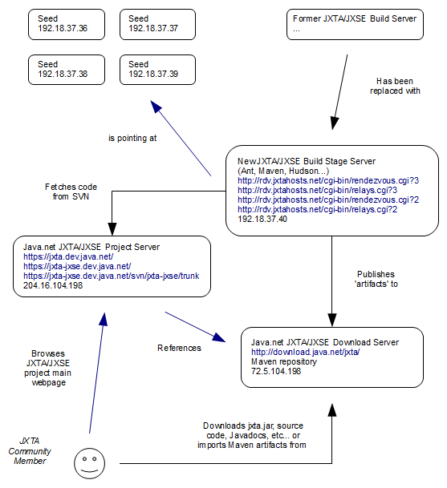
At the end of 2008, the server used by the JXTA/JXSE community crashed. Some backup data could be restored, but the release system integrated with Java.net was broken. A new build stage server has been made available by Sun Microsystems for the community. Amongst others, this is where the list of default seeds and rendezvous relays could be fetched.
The idea was to retrieve (i.e., check-out) code from the Subversion repository on the Java.net JXTA/JXSE project server, build artifacts on the new build stage server and publish them on the Java.net JXTA/JXSE download server. Then users, browsing the main JXTA/JXSE web pages from the project server, would be redirected to the download server to download jxta.jar, code, documentation etc... for release 2.6, like they do for release 2.5 now.
Unfortunately, a) the new build stage server turns out to have some OpenSolaris installation issues which cannot be solved without the help of a system administrator and no support could be obtained to solve this issue, b) restoring the release process to Java.net is technically complex and subject to failures requiring access to the server to solve them and a good knowledge of OpenSolaris which does not seem to be available in the community, and c) the support, functionalities and web server response time offered by Java.net have become too insufficient to support the communities' effort.
Default Community Seeds
Although the JXSE code still contains references to the default communities seeds, these have not been maintained and are not operational anymore.
Moving from Java.net to Kenaï
It has been decided to move the JXTA/JXSE project from Java.net to project Kenaï. This process has started in November 2009 and will go through early 2010, in collaboration with Kenaï support. Two subprojects have been created:
- JXTA - For the JXTA protocol specifications (http://kenai.com/projects/jxta).
- JXSE - For the Java implementation of the JXTA protocol specifications (http://kenai.com/projects/jxse). This is where the new subversion repository will be located and from which the code can be checked out.
Project Kenaï offers better functionality that Java.net, in an integrated environment, together with better support.

Appendix A: EndpointService Diagrams
This appendix contains diagrams helping understanding what is happening under the hood of JXSE.
Endpoint Service – getMessenger()
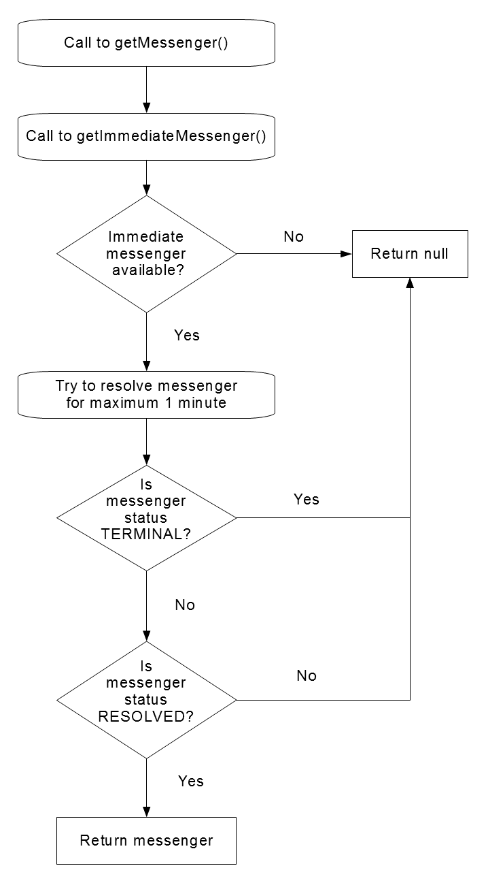

Endpoint Service – getMessengerImmediate()
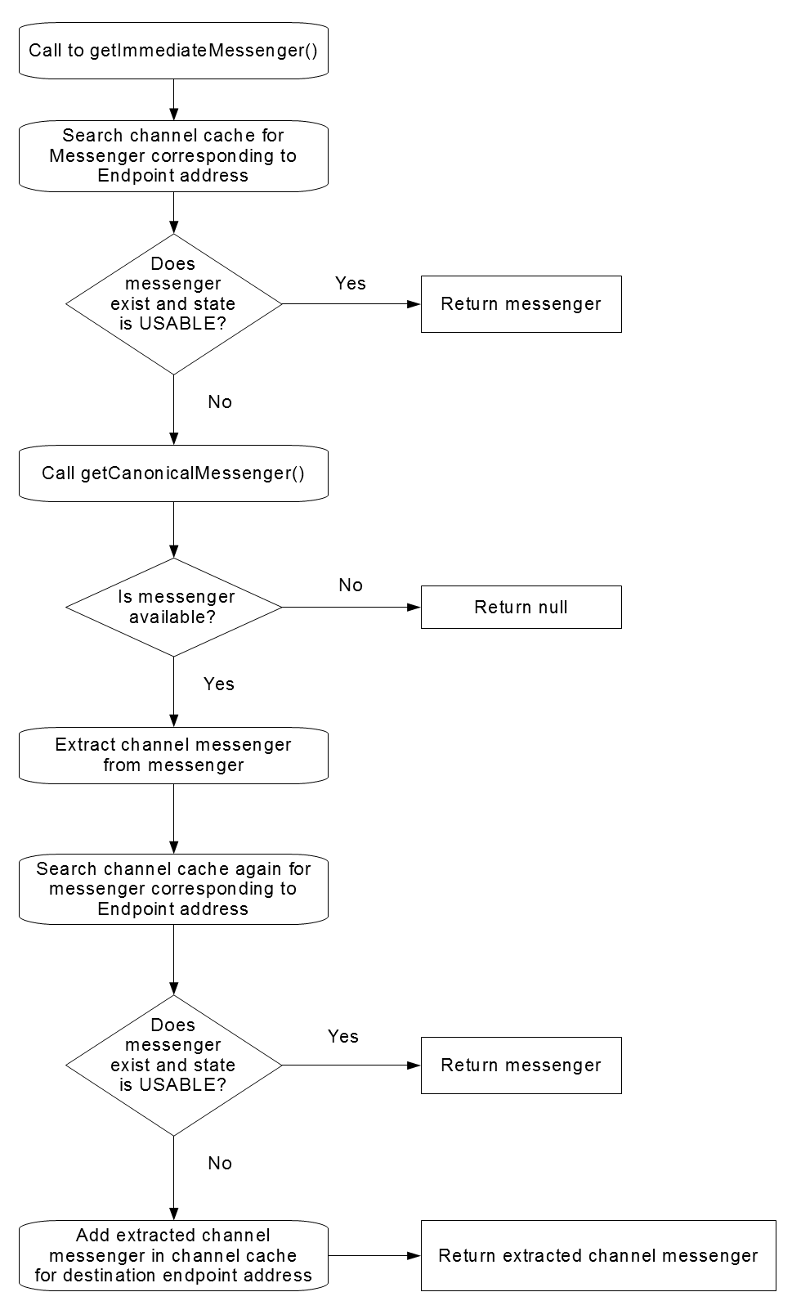

Endpoint Service – getCanonicalMessage()
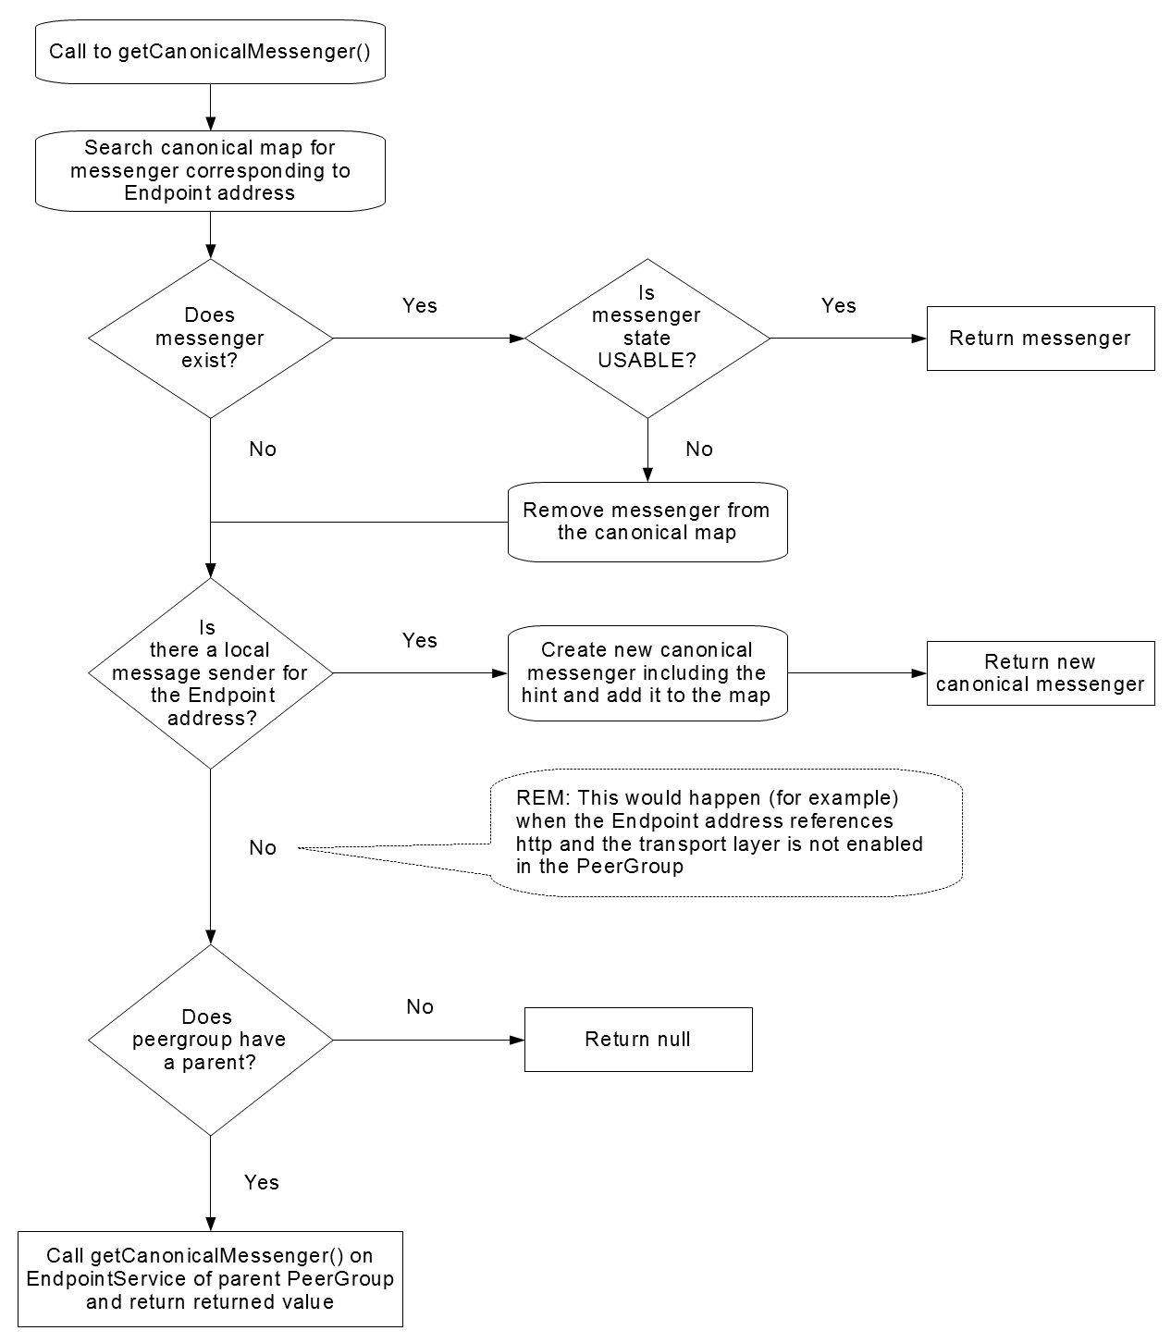

Endpoint Service – getDirectMessenger()
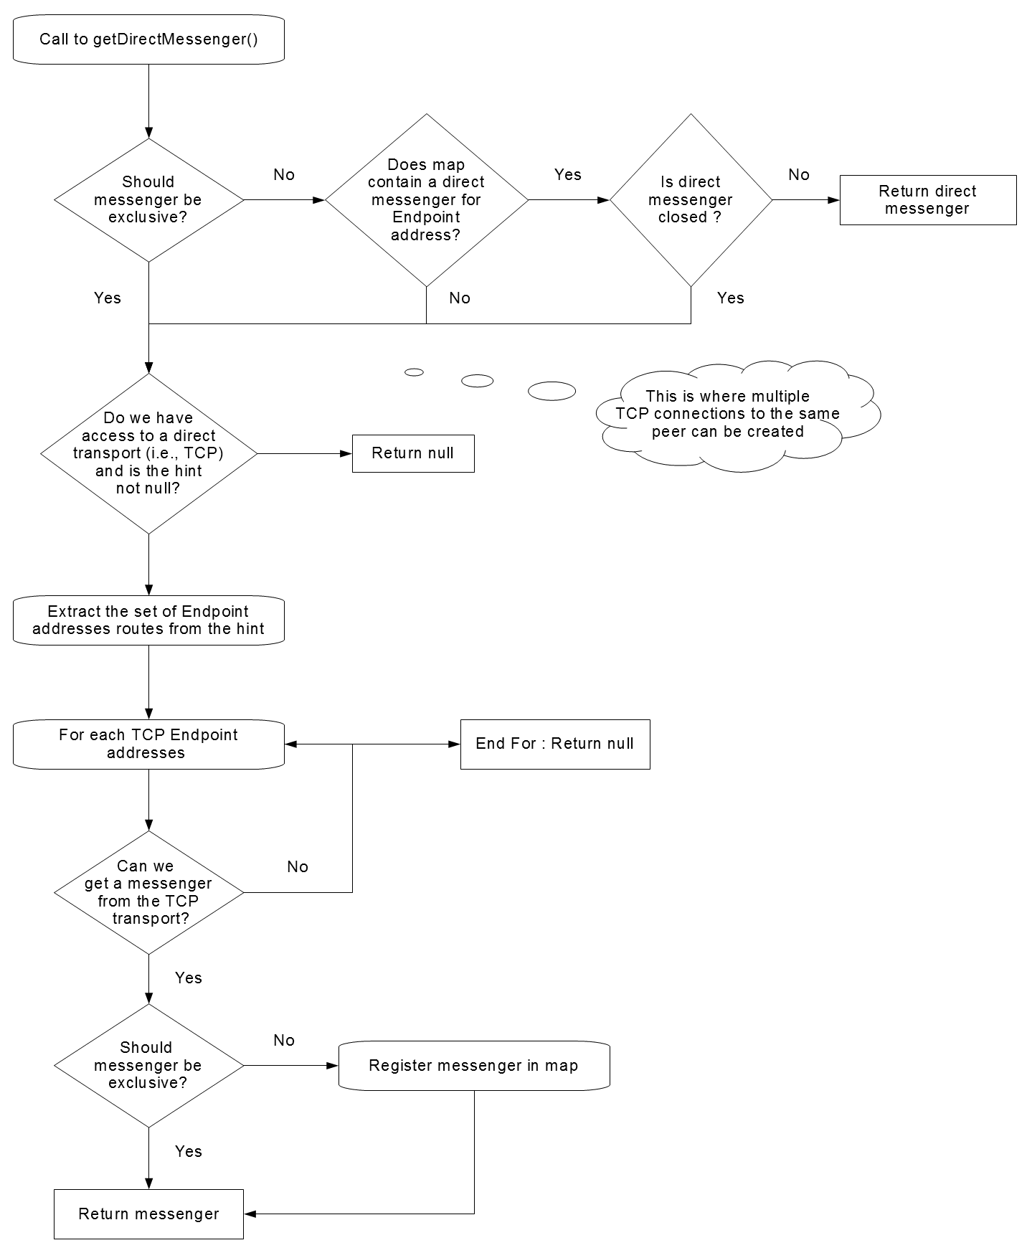

Canonical Messenger
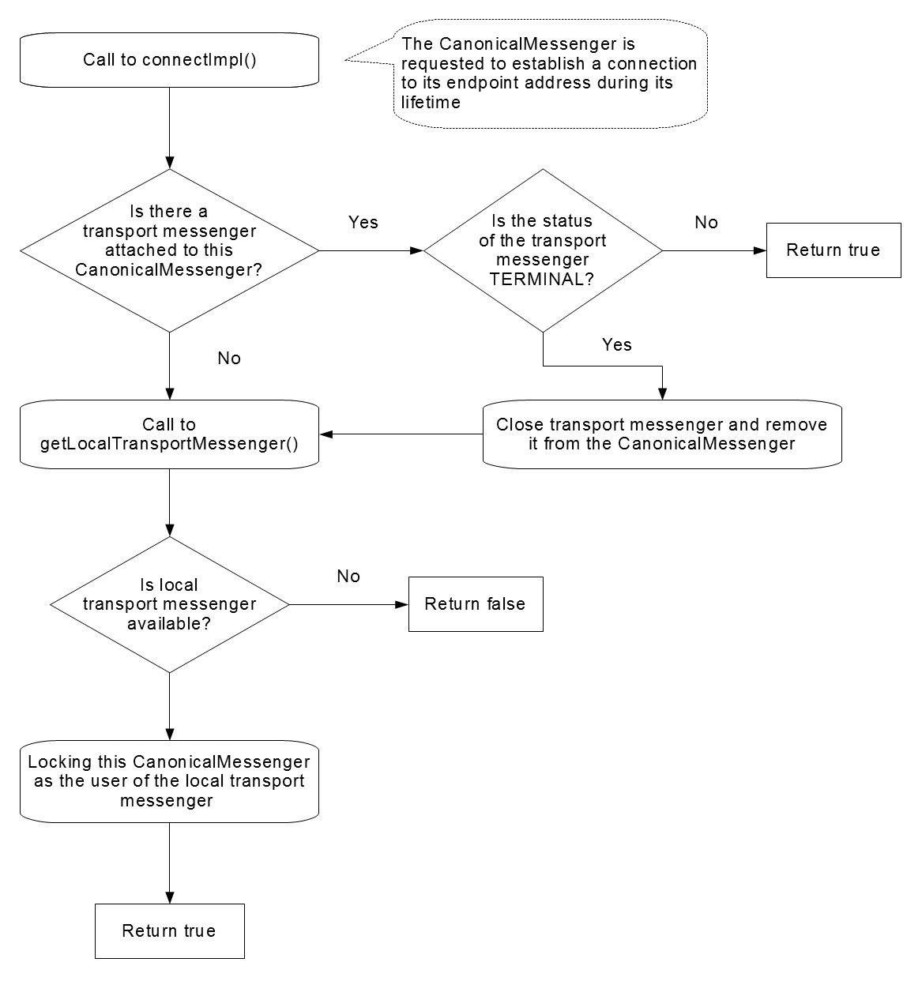

Endpoint Service – getLocalTransportMessenger()
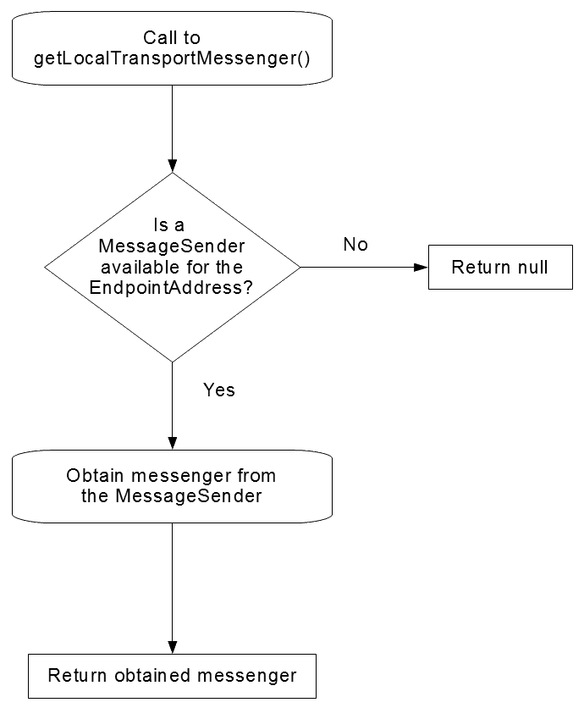

Message Sender – getMessenger()
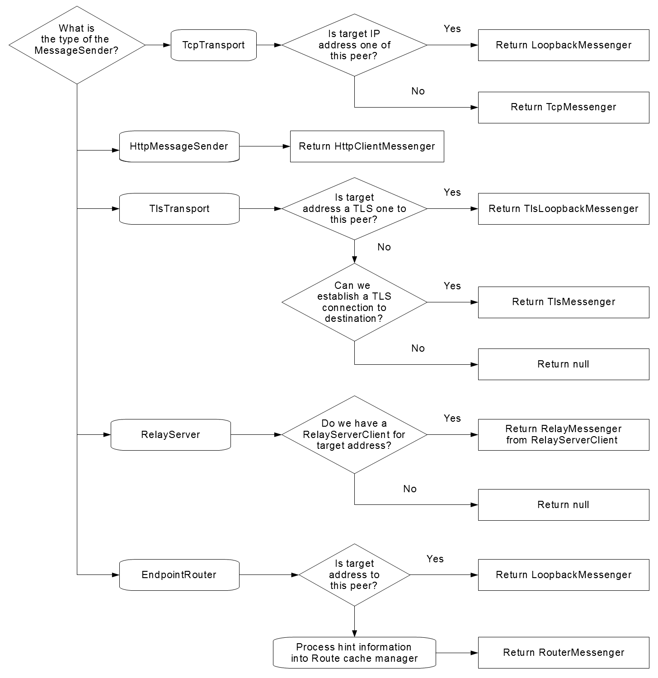

From Messengers to MessageSenders
This diagram shows the relationship between Messengers invoked via the EndpointService and MessageSenders physically sending messages:
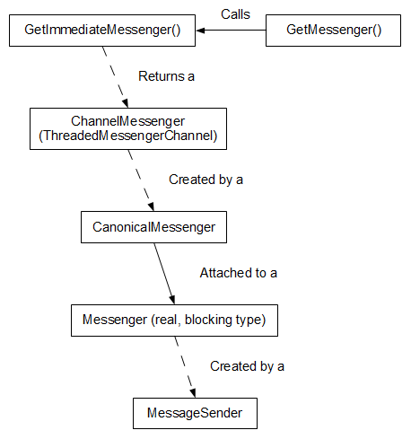
Hint Processing
This diagram explains how hints (i.e., route suggestions) are taken into account when messengers are retrieved from the Endpoint service:
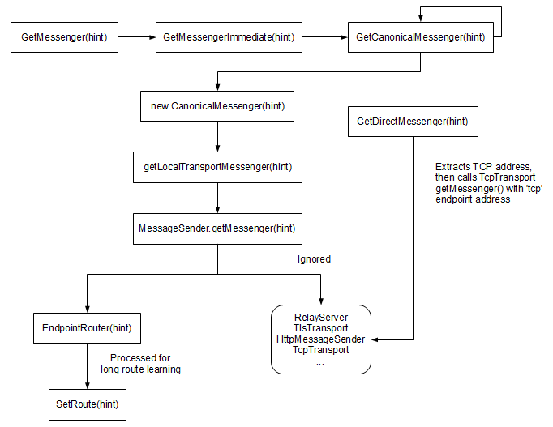
Appendix B: Pipe Diagrams
This appendix contains diagrams describing objects implementing pipes in JXSE.
Input Pipe
Inheritance structure:
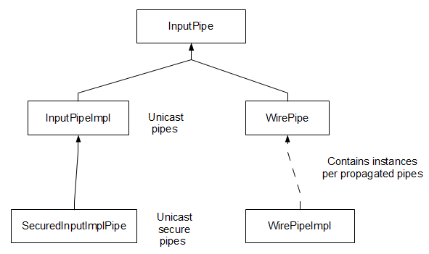

Output Pipe
Inheritance structure:
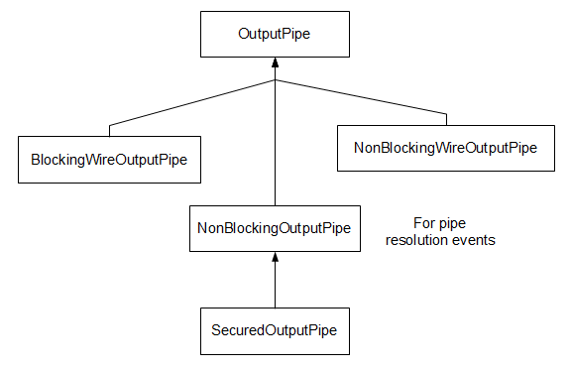

Appendix C: Connection Monitor Example
This appendix contains the complete code for the connection monitor example.
Connectivity Monitor
/**
* This frame collects and displays connectivity information from a peergroup.
*/
public class ConnectivityMonitor extends JFrame implements Runnable {

// Static

public static final ScheduledExecutorService TheExecutor = Executors.newScheduledThreadPool(5);

// Attributes

private final JFrame ThisFrame;

private PeerGroup ThePeerGroup = null;

private Future TheMonitorFuture = null;

private DefaultTableModel LocalRDVs_TM = null;
private String[] LocalRDV_Col = { "Local RDV View IDs" };

private DefaultTableModel LocalEdges_TM = null;
private String[] LocalEdge_Col = { "Local EDGE View IDs" };

private static final String[][] EmptyTableContent = new String[0][1];

private ArrayList<LogEntry> TheLogs = new ArrayList<LogEntry>();

private static final SimpleDateFormat TheDateFormat =
new SimpleDateFormat("'['HH:mm:ss']'");

/** Creates new form ConnectivityMonitor */
public ConnectivityMonitor(PeerGroup inGroup) {

// Registering as rendezvous event listener
inGroup.getRendezVousService().addListener(new RdvEventMonitor(this));

// Registering this JFrame
ThisFrame = this;

// JFrame initialization
initComponents();

// Displaying the frame on the awt queue
SetDefaultLookAndFeel();
putScreenAtTheCenter(this);
resettingFrameValues();

java.awt.EventQueue.invokeLater(new Runnable() {
public void run() {
ThisFrame.setVisible(true);
}
});

// Initialization
ThePeerGroup = inGroup;

// Setting own default table models
LocalRDVs_TM = new DefaultTableModel(EmptyTableContent, LocalRDV_Col);
this.LocalRDVTable.setModel(LocalRDVs_TM);

LocalEdges_TM = new DefaultTableModel(EmptyTableContent, LocalEdge_Col);
this.LocalEdgeTable.setModel(LocalEdges_TM);

// Starting the monitor
TheLogs.add(new LogEntry(new Date(System.currentTimeMillis()),
"Starting to monitor the peergroup"));

TheMonitorFuture = TheExecutor.scheduleWithFixedDelay(this, 0, 1, TimeUnit.SECONDS);

}

public static void SetDefaultLookAndFeel() {

try {
UIManager.setLookAndFeel(UIManager.getSystemLookAndFeelClassName());
} catch (ClassNotFoundException Ex) {
System.err.println(Ex.toString());
} catch (InstantiationException Ex) {
System.err.println(Ex.toString());
} catch (IllegalAccessException Ex) {
System.err.println(Ex.toString());
} catch (UnsupportedLookAndFeelException Ex) {
System.err.println(Ex.toString());

}

}

public static void putScreenAtTheCenter(Component TheComponent) {

// Retrieving horizontal value
int WidthPosition = (Toolkit.getDefaultToolkit().getScreenSize().width
- TheComponent.getWidth()) / 2;

int HeightPosition = (Toolkit.getDefaultToolkit().getScreenSize().height
- TheComponent.getHeight()) / 2;

TheComponent.setLocation(WidthPosition, HeightPosition);

}

/** This method is called from within the constructor to
* initialize the form.
* WARNING: Do NOT modify this code. The content of this method is
* always regenerated by the Form Editor.
*/
@SuppressWarnings("unchecked")
// <editor-fold defaultstate="collapsed" desc="Generated Code">
private void initComponents() {

StatusPane = new javax.swing.JPanel();
PeerIDLabel = new javax.swing.JLabel();
PeerNameTextField = new javax.swing.JTextField();
PeerGroupIDLabel = new javax.swing.JLabel();
PeerGroupNameTextField = new javax.swing.JTextField();
ParentGroupLabel = new javax.swing.JLabel();
ParentGroupNameTextField = new javax.swing.JTextField();
PeerIDTextField = new javax.swing.JTextField();
PeerGroupIDTextField = new javax.swing.JTextField();
ParentGroupIDTextField = new javax.swing.JTextField();
ScrollLogPane = new javax.swing.JScrollPane();
LogPane = new javax.swing.JTextPane();
DisplayPanel = new javax.swing.JPanel();
jScrollPane1 = new javax.swing.JScrollPane();
LocalEdgeTable = new javax.swing.JTable();
jScrollPane2 = new javax.swing.JScrollPane();
LocalRDVTable = new javax.swing.JTable();
IsConnectedToRelayTextField = new javax.swing.JTextField();
IsConnectedToRelayCheckBox = new javax.swing.JCheckBox();
IsConnectedToRDVCheckBox = new javax.swing.JCheckBox();
CurrentModeLabel2 = new javax.swing.JLabel();
AliveRadioButton = new javax.swing.JRadioButton();
IsRDVCheckBox = new javax.swing.JCheckBox();

setDefaultCloseOperation(javax.swing.WindowConstants.EXIT_ON_CLOSE);
setResizable(false);
addWindowListener(new java.awt.event.WindowAdapter() {
public void windowClosed(java.awt.event.WindowEvent evt) {
formWindowClosed(evt);
}
});

PeerIDLabel.setFont(new java.awt.Font("Tahoma", 1, 11));
PeerIDLabel.setText("Peer");

PeerNameTextField.setEditable(false);
PeerNameTextField.setFont(new java.awt.Font("Tahoma", 0, 9));

PeerGroupIDLabel.setFont(new java.awt.Font("Tahoma", 1, 11));
PeerGroupIDLabel.setText("Peer Group");

PeerGroupNameTextField.setEditable(false);
PeerGroupNameTextField.setFont(new java.awt.Font("Tahoma", 0, 9));

ParentGroupLabel.setFont(new java.awt.Font("Tahoma", 1, 11));
ParentGroupLabel.setText("Parent Group");

ParentGroupNameTextField.setEditable(false);
ParentGroupNameTextField.setFont(new java.awt.Font("Tahoma", 0, 9));

PeerIDTextField.setEditable(false);
PeerIDTextField.setFont(new java.awt.Font("Tahoma", 0, 9));

PeerGroupIDTextField.setEditable(false);
PeerGroupIDTextField.setFont(new java.awt.Font("Tahoma", 0, 9));

ParentGroupIDTextField.setEditable(false);
ParentGroupIDTextField.setFont(new java.awt.Font("Tahoma", 0, 9));

LogPane.setEditable(false);
LogPane.setFont(new java.awt.Font("Tahoma", 0, 9));
LogPane.setName("LogPane"); // NOI18N
ScrollLogPane.setViewportView(LogPane);

javax.swing.GroupLayout StatusPaneLayout = new javax.swing.GroupLayout(StatusPane);
StatusPane.setLayout(StatusPaneLayout);
StatusPaneLayout.setHorizontalGroup(
StatusPaneLayout.createParallelGroup(javax.swing.GroupLayout.Alignment.LEADING)
.addGroup(javax.swing.GroupLayout.Alignment.TRAILING, StatusPaneLayout.createSequentialGroup()
.addContainerGap()
.addGroup(StatusPaneLayout.createParallelGroup(javax.swing.GroupLayout.Alignment.TRAILING)
.addComponent(ScrollLogPane, javax.swing.GroupLayout.Alignment.LEADING, javax.swing.GroupLayout.DEFAULT_SIZE, 401, Short.MAX_VALUE)
.addComponent(PeerGroupIDTextField, javax.swing.GroupLayout.Alignment.LEADING, javax.swing.GroupLayout.DEFAULT_SIZE, 401, Short.MAX_VALUE)
.addComponent(PeerIDTextField, javax.swing.GroupLayout.DEFAULT_SIZE, 401, Short.MAX_VALUE)
.addGroup(javax.swing.GroupLayout.Alignment.LEADING, StatusPaneLayout.createSequentialGroup()
.addComponent(PeerIDLabel)
.addPreferredGap(javax.swing.LayoutStyle.ComponentPlacement.UNRELATED)
.addComponent(PeerNameTextField, javax.swing.GroupLayout.DEFAULT_SIZE, 365, Short.MAX_VALUE))
.addGroup(javax.swing.GroupLayout.Alignment.LEADING, StatusPaneLayout.createSequentialGroup()
.addComponent(ParentGroupLabel)
.addPreferredGap(javax.swing.LayoutStyle.ComponentPlacement.UNRELATED)
.addComponent(ParentGroupNameTextField, javax.swing.GroupLayout.DEFAULT_SIZE, 316, Short.MAX_VALUE))
.addGroup(javax.swing.GroupLayout.Alignment.LEADING, StatusPaneLayout.createSequentialGroup()
.addComponent(PeerGroupIDLabel)
.addPreferredGap(javax.swing.LayoutStyle.ComponentPlacement.UNRELATED)
.addComponent(PeerGroupNameTextField, javax.swing.GroupLayout.DEFAULT_SIZE, 328, Short.MAX_VALUE))
.addComponent(ParentGroupIDTextField, javax.swing.GroupLayout.Alignment.LEADING, javax.swing.GroupLayout.DEFAULT_SIZE, 401, Short.MAX_VALUE))
.addContainerGap())
);
StatusPaneLayout.setVerticalGroup(
StatusPaneLayout.createParallelGroup(javax.swing.GroupLayout.Alignment.LEADING)
.addGroup(StatusPaneLayout.createSequentialGroup()
.addContainerGap()
.addGroup(StatusPaneLayout.createParallelGroup(javax.swing.GroupLayout.Alignment.BASELINE)
.addComponent(PeerIDLabel)
.addComponent(PeerNameTextField, javax.swing.GroupLayout.PREFERRED_SIZE, javax.swing.GroupLayout.DEFAULT_SIZE, javax.swing.GroupLayout.PREFERRED_SIZE))
.addPreferredGap(javax.swing.LayoutStyle.ComponentPlacement.RELATED)
.addComponent(PeerIDTextField, javax.swing.GroupLayout.PREFERRED_SIZE, javax.swing.GroupLayout.DEFAULT_SIZE, javax.swing.GroupLayout.PREFERRED_SIZE)
.addPreferredGap(javax.swing.LayoutStyle.ComponentPlacement.RELATED)
.addGroup(StatusPaneLayout.createParallelGroup(javax.swing.GroupLayout.Alignment.BASELINE)
.addComponent(PeerGroupIDLabel)
.addComponent(PeerGroupNameTextField, javax.swing.GroupLayout.PREFERRED_SIZE, javax.swing.GroupLayout.DEFAULT_SIZE, javax.swing.GroupLayout.PREFERRED_SIZE))
.addPreferredGap(javax.swing.LayoutStyle.ComponentPlacement.RELATED)
.addComponent(PeerGroupIDTextField, javax.swing.GroupLayout.PREFERRED_SIZE, javax.swing.GroupLayout.DEFAULT_SIZE, javax.swing.GroupLayout.PREFERRED_SIZE)
.addPreferredGap(javax.swing.LayoutStyle.ComponentPlacement.RELATED)
.addGroup(StatusPaneLayout.createParallelGroup(javax.swing.GroupLayout.Alignment.BASELINE)
.addComponent(ParentGroupLabel)
.addComponent(ParentGroupNameTextField, javax.swing.GroupLayout.PREFERRED_SIZE, javax.swing.GroupLayout.DEFAULT_SIZE, javax.swing.GroupLayout.PREFERRED_SIZE))
.addPreferredGap(javax.swing.LayoutStyle.ComponentPlacement.RELATED)
.addComponent(ParentGroupIDTextField, javax.swing.GroupLayout.PREFERRED_SIZE, javax.swing.GroupLayout.DEFAULT_SIZE, javax.swing.GroupLayout.PREFERRED_SIZE)
.addGap(18, 18, 18)
.addComponent(ScrollLogPane, javax.swing.GroupLayout.DEFAULT_SIZE, 269, Short.MAX_VALUE))
);

LocalEdgeTable.setFont(new java.awt.Font("Tahoma", 0, 9));
LocalEdgeTable.setModel(new javax.swing.table.DefaultTableModel(
new Object [][] {
{null}
},
new String [] {
"Local Edge View IDs"
}
) {
Class[] types = new Class [] {
java.lang.String.class
};
boolean[] canEdit = new boolean [] {
false
};

public Class getColumnClass(int columnIndex) {
return types [columnIndex];
}

public boolean isCellEditable(int rowIndex, int columnIndex) {
return canEdit [columnIndex];
}
});
jScrollPane1.setViewportView(LocalEdgeTable);
LocalEdgeTable.getColumnModel().getColumn(0).setResizable(false);

LocalRDVTable.setFont(new java.awt.Font("Tahoma", 0, 9));
LocalRDVTable.setModel(new javax.swing.table.DefaultTableModel(
new Object [][] {
{null}
},
new String [] {
"Local RDV View IDs"
}
) {
Class[] types = new Class [] {
java.lang.String.class
};
boolean[] canEdit = new boolean [] {
false
};

public Class getColumnClass(int columnIndex) {
return types [columnIndex];
}

public boolean isCellEditable(int rowIndex, int columnIndex) {
return canEdit [columnIndex];
}
});
jScrollPane2.setViewportView(LocalRDVTable);
LocalRDVTable.getColumnModel().getColumn(0).setResizable(false);

IsConnectedToRelayTextField.setEditable(false);
IsConnectedToRelayTextField.setFont(new java.awt.Font("Tahoma", 0, 9));

IsConnectedToRelayCheckBox.setFont(new java.awt.Font("Tahoma", 1, 11));
IsConnectedToRelayCheckBox.setText("is connected to Relay");
IsConnectedToRelayCheckBox.addActionListener(new java.awt.event.ActionListener() {
public void actionPerformed(java.awt.event.ActionEvent evt) {
IsConnectedToRelayCheckBoxActionPerformed(evt);
}
});

IsConnectedToRDVCheckBox.setFont(new java.awt.Font("Tahoma", 1, 11));
IsConnectedToRDVCheckBox.setText("is connected to RDV");
IsConnectedToRDVCheckBox.addActionListener(new java.awt.event.ActionListener() {
public void actionPerformed(java.awt.event.ActionEvent evt) {
IsConnectedToRDVCheckBoxActionPerformed(evt);
}
});

CurrentModeLabel2.setFont(new java.awt.Font("Tahoma", 1, 11));
CurrentModeLabel2.setText("Relay ID");

AliveRadioButton.setFont(new java.awt.Font("Tahoma", 1, 11));
AliveRadioButton.setText("Alive");

IsRDVCheckBox.setFont(new java.awt.Font("Tahoma", 1, 11));
IsRDVCheckBox.setText("is RDV");
IsRDVCheckBox.addActionListener(new java.awt.event.ActionListener() {
public void actionPerformed(java.awt.event.ActionEvent evt) {
IsRDVCheckBoxActionPerformed(evt);
}
});

javax.swing.GroupLayout DisplayPanelLayout = new javax.swing.GroupLayout(DisplayPanel);
DisplayPanel.setLayout(DisplayPanelLayout);
DisplayPanelLayout.setHorizontalGroup(
DisplayPanelLayout.createParallelGroup(javax.swing.GroupLayout.Alignment.LEADING)
.addGroup(DisplayPanelLayout.createSequentialGroup()
.addContainerGap()
.addGroup(DisplayPanelLayout.createParallelGroup(javax.swing.GroupLayout.Alignment.LEADING)
.addComponent(jScrollPane2, javax.swing.GroupLayout.DEFAULT_SIZE, 372, Short.MAX_VALUE)
.addComponent(jScrollPane1, javax.swing.GroupLayout.DEFAULT_SIZE, 372, Short.MAX_VALUE)
.addComponent(IsConnectedToRelayTextField, javax.swing.GroupLayout.DEFAULT_SIZE, 372, Short.MAX_VALUE)
.addGroup(javax.swing.GroupLayout.Alignment.TRAILING, DisplayPanelLayout.createSequentialGroup()
.addGroup(DisplayPanelLayout.createParallelGroup(javax.swing.GroupLayout.Alignment.LEADING)
.addComponent(CurrentModeLabel2)
.addComponent(AliveRadioButton))
.addPreferredGap(javax.swing.LayoutStyle.ComponentPlacement.RELATED, 93, Short.MAX_VALUE)
.addComponent(IsRDVCheckBox)
.addGap(18, 18, 18)
.addGroup(DisplayPanelLayout.createParallelGroup(javax.swing.GroupLayout.Alignment.LEADING)
.addComponent(IsConnectedToRDVCheckBox)
.addComponent(IsConnectedToRelayCheckBox))))
.addContainerGap())
);
DisplayPanelLayout.setVerticalGroup(
DisplayPanelLayout.createParallelGroup(javax.swing.GroupLayout.Alignment.LEADING)
.addGroup(javax.swing.GroupLayout.Alignment.TRAILING, DisplayPanelLayout.createSequentialGroup()
.addContainerGap()
.addGroup(DisplayPanelLayout.createParallelGroup(javax.swing.GroupLayout.Alignment.BASELINE)
.addComponent(IsConnectedToRDVCheckBox)
.addComponent(AliveRadioButton)
.addComponent(IsRDVCheckBox))
.addPreferredGap(javax.swing.LayoutStyle.ComponentPlacement.UNRELATED)
.addGroup(DisplayPanelLayout.createParallelGroup(javax.swing.GroupLayout.Alignment.BASELINE)
.addComponent(IsConnectedToRelayCheckBox, javax.swing.GroupLayout.PREFERRED_SIZE, 23, javax.swing.GroupLayout.PREFERRED_SIZE)
.addComponent(CurrentModeLabel2, javax.swing.GroupLayout.PREFERRED_SIZE, 17, javax.swing.GroupLayout.PREFERRED_SIZE))
.addPreferredGap(javax.swing.LayoutStyle.ComponentPlacement.RELATED, 6, Short.MAX_VALUE)
.addComponent(IsConnectedToRelayTextField, javax.swing.GroupLayout.PREFERRED_SIZE, javax.swing.GroupLayout.DEFAULT_SIZE, javax.swing.GroupLayout.PREFERRED_SIZE)
.addGap(18, 18, 18)
.addComponent(jScrollPane2, javax.swing.GroupLayout.PREFERRED_SIZE, 111, javax.swing.GroupLayout.PREFERRED_SIZE)
.addGap(18, 18, 18)
.addComponent(jScrollPane1, javax.swing.GroupLayout.PREFERRED_SIZE, 192, javax.swing.GroupLayout.PREFERRED_SIZE)
.addContainerGap())
);

javax.swing.GroupLayout layout = new javax.swing.GroupLayout(getContentPane());
getContentPane().setLayout(layout);
layout.setHorizontalGroup(
layout.createParallelGroup(javax.swing.GroupLayout.Alignment.LEADING)
.addGroup(javax.swing.GroupLayout.Alignment.TRAILING, layout.createSequentialGroup()
.addComponent(StatusPane, javax.swing.GroupLayout.DEFAULT_SIZE, javax.swing.GroupLayout.DEFAULT_SIZE, Short.MAX_VALUE)
.addPreferredGap(javax.swing.LayoutStyle.ComponentPlacement.RELATED)
.addComponent(DisplayPanel, javax.swing.GroupLayout.PREFERRED_SIZE, javax.swing.GroupLayout.DEFAULT_SIZE, javax.swing.GroupLayout.PREFERRED_SIZE))
);
layout.setVerticalGroup(
layout.createParallelGroup(javax.swing.GroupLayout.Alignment.LEADING)
.addGroup(layout.createSequentialGroup()
.addGap(11, 11, 11)
.addComponent(DisplayPanel, javax.swing.GroupLayout.DEFAULT_SIZE, javax.swing.GroupLayout.DEFAULT_SIZE, Short.MAX_VALUE))
.addGroup(layout.createSequentialGroup()
.addComponent(StatusPane, javax.swing.GroupLayout.DEFAULT_SIZE, javax.swing.GroupLayout.DEFAULT_SIZE, Short.MAX_VALUE)
.addGap(11, 11, 11))
);

pack();
}// </editor-fold>

private void IsConnectedToRelayCheckBoxActionPerformed(java.awt.event.ActionEvent evt) {
// TODO add your handling code here:
}

private void formWindowClosed(java.awt.event.WindowEvent evt) {

// Stopping monitor task
stopMonitorTask();

}

private void IsConnectedToRDVCheckBoxActionPerformed(java.awt.event.ActionEvent evt) {
// TODO add your handling code here:
}

private void IsRDVCheckBoxActionPerformed(java.awt.event.ActionEvent evt) {
// TODO add your handling code here:
}

private synchronized void stopMonitorTask() {

if ( TheMonitorFuture != null ) {
TheMonitorFuture.cancel(false);
}

}

@Override
protected void finalize() {

// Stopping monitor task
stopMonitorTask();

}

// Variables declaration - do not modify
private javax.swing.JRadioButton AliveRadioButton;
private javax.swing.JLabel CurrentModeLabel2;
private javax.swing.JPanel DisplayPanel;
private javax.swing.JCheckBox IsConnectedToRDVCheckBox;
private javax.swing.JCheckBox IsConnectedToRelayCheckBox;
private javax.swing.JTextField IsConnectedToRelayTextField;
private javax.swing.JCheckBox IsRDVCheckBox;
private javax.swing.JTable LocalEdgeTable;
private javax.swing.JTable LocalRDVTable;
private javax.swing.JTextPane LogPane;
private javax.swing.JTextField ParentGroupIDTextField;
private javax.swing.JLabel ParentGroupLabel;
private javax.swing.JTextField ParentGroupNameTextField;
private javax.swing.JLabel PeerGroupIDLabel;
private javax.swing.JTextField PeerGroupIDTextField;
private javax.swing.JTextField PeerGroupNameTextField;
private javax.swing.JLabel PeerIDLabel;
private javax.swing.JTextField PeerIDTextField;
private javax.swing.JTextField PeerNameTextField;
private javax.swing.JScrollPane ScrollLogPane;
private javax.swing.JPanel StatusPane;
private javax.swing.JScrollPane jScrollPane1;
private javax.swing.JScrollPane jScrollPane2;
// End of variables declaration

public void resettingFrameValues() {

// Resetting frame value
this.setTitle("Connectivity Monitor");

this.PeerNameTextField.setText("<unknown>");
this.PeerIDTextField.setText("");

this.PeerGroupNameTextField.setText("<unknown>");
this.PeerGroupIDTextField.setText("");

this.ParentGroupNameTextField.setText("<unknown>");
this.ParentGroupIDTextField.setText("");

this.IsConnectedToRelayCheckBox.setSelected(false);
this.IsConnectedToRDVCheckBox.setSelected(false);

}

private void updateTableContent(DefaultTableModel inTM, List<String> inNewContent, String[] inColumns) {

// Do we have the same number of elements
if ( inTM.getRowCount() == inNewContent.size() ) {

// Sorting new candidates
Collections.sort(inNewContent);

// Replacing items that have to be replaced
for (int i=0;i<inNewContent.size();i++) {

if ( inNewContent.get(i).compareTo((String) inTM.getValueAt(i, 0)) != 0 )
inTM.setValueAt(inNewContent.get(i), i, 0);

}

// Done
return;

}

// We need a new data vector
String[][] NewContent = new String[inNewContent.size()][1];
for (int i=0;i<inNewContent.size();i++) NewContent[i][0] = inNewContent.get(i);
inTM.setDataVector(NewContent, inColumns);

}

public void run() {

// Alive notification
this.AliveRadioButton.setSelected(!this.AliveRadioButton.isSelected());

if ( this.ThePeerGroup == null ) {

LogEntry TheEntry = new LogEntry(new Date(System.currentTimeMillis()),
"Monitored peergroup is NULL");
this.TheLogs.add(TheEntry);

// Resetting frame value
resettingFrameValues();

return;

}

this.setTitle("Connectivity Monitor - "
+ ThePeerGroup.getPeerName() + " - "
+ ThePeerGroup.getPeerID().toString());

this.PeerNameTextField.setText(ThePeerGroup.getPeerName());
this.PeerIDTextField.setText(ThePeerGroup.getPeerID().toString());

this.PeerGroupNameTextField.setText(ThePeerGroup.getPeerGroupName());
this.PeerGroupIDTextField.setText(ThePeerGroup.getPeerGroupID().toString());

PeerGroup ParentPG = this.ThePeerGroup.getParentGroup();

if ( ParentPG != null) {

this.ParentGroupNameTextField.setText(ParentPG.getPeerGroupName());
this.ParentGroupIDTextField.setText(ParentPG.getPeerGroupID().toString());

}

RendezVousService TmpRDVS = this.ThePeerGroup.getRendezVousService();

if ( TmpRDVS != null ) {

this.IsRDVCheckBox.setSelected(TmpRDVS.isRendezVous());
this.IsConnectedToRDVCheckBox.setSelected(TmpRDVS.isConnectedToRendezVous());

List<PeerID> Items = TmpRDVS.getLocalRendezVousView();

// Sorting Peer IDs
List<String> StrItems = new ArrayList<String>();
for (int i=0;i<Items.size();i++)
StrItems.add(Items.get(i).toString());

updateTableContent(LocalRDVs_TM, StrItems, LocalRDV_Col);

} else {

TheLogs.add(new LogEntry(new Date(System.currentTimeMillis()),
"Rendezvous service is NULL"));

}

EndpointService TmpRelay = this.ThePeerGroup.getEndpointService();

if ( TmpRelay != null ) {

this.IsConnectedToRelayCheckBox.setSelected(TmpRelay.isConnectedToRelayPeer());

List<PeerID> Items = TmpRDVS.getLocalEdgeView();

// Sorting Peer IDs
List<String> StrItems = new ArrayList<String>();
for (int i=0;i<Items.size();i++)
StrItems.add(Items.get(i).toString());

updateTableContent(LocalEdges_TM, StrItems, LocalEdge_Col);

} else {

TheLogs.add(new LogEntry(new Date(System.currentTimeMillis()),
"Endpoint service is NULL"));

}

// Adding logs

String Content = "";
Collections.sort(TheLogs);

for (int i=(TheLogs.size()-1);i>=0;i--)
Content = Content + TheDateFormat.format(TheLogs.get(i).TheDate)
+ " " + TheLogs.get(i).TheLog + "\n";

LogPane.setText(Content);

}

private static class LogEntry implements Comparable<LogEntry> {

public Date TheDate = null;
public String TheLog = null;

public LogEntry(Date inDate, String inLog) {

TheDate = inDate;
TheLog = inLog;

}

public int compareTo(LogEntry o) {

if ( o == null ) return 1;

return TheDate.compareTo(o.TheDate);

}

}

public static class RdvEventMonitor implements RendezvousListener {

private ConnectivityMonitor TheMonitor = null;

public RdvEventMonitor(ConnectivityMonitor inCM) {

TheMonitor = inCM;

}

public void rendezvousEvent(RendezvousEvent event) {

if ( event == null ) return;

Date TimeStamp = new Date(System.currentTimeMillis());
String Log = null;

if ( event.getType() == RendezvousEvent.RDVCONNECT ) {
Log = "Connection to RDV";
} else if ( event.getType() == RendezvousEvent.RDVRECONNECT ) {
Log = "Reconnection to RDV";
} else if ( event.getType() == RendezvousEvent.CLIENTCONNECT ) {
Log = "EDGE client connection";
} else if ( event.getType() == RendezvousEvent.CLIENTRECONNECT ) {
Log = "EDGE client reconnection";
} else if ( event.getType() == RendezvousEvent.RDVDISCONNECT ) {
Log = "Disconnection from RDV";
} else if ( event.getType() == RendezvousEvent.RDVFAILED ) {
Log = "Connection to RDV failed";
} else if ( event.getType() == RendezvousEvent.CLIENTDISCONNECT ) {
Log = "EDGE client disconnection from RDV";
} else if ( event.getType() == RendezvousEvent.CLIENTFAILED ) {
Log = "EDGE client connection to RDV failed";
} else if ( event.getType() == RendezvousEvent.BECAMERDV ) {
Log = "This peer became RDV";
} else if ( event.getType() == RendezvousEvent.BECAMEEDGE ) {
Log = "This peer became EDGE";
}

String TempPID = event.getPeer();
if ( TempPID != null ) Log = Log + "\n " + TempPID;

// Adding the entry
TheMonitor.TheLogs.add(new LogEntry(TimeStamp, Log));

}

}

}

DelayedJxtaNetworkStopper

public class DelayedJxtaNetworkStopper implements Runnable {

// Attributes

private final NetworkManager TheNM;
private String TheMsg = "";
private String TheTitle = "";

public DelayedJxtaNetworkStopper(NetworkManager inNM, String inMsg, String inTitle) {

TheNM = inNM;
TheMsg = inMsg;
TheTitle = inTitle;

}

public void run() {

// Creating the dialog box
JOptionPane pane = new JOptionPane(TheMsg, JOptionPane.INFORMATION_MESSAGE);
JDialog dialog = pane.createDialog(TheTitle);

// Displaying the message in a non-modal way
dialog.setModal(false);
dialog.setVisible(true);

// Waiting for user to click ok
Object click = null;

do {
click = pane.getValue();
if ( JOptionPane.UNINITIALIZED_VALUE == click )
try { Thread.sleep(200); } catch (InterruptedException ex) {}
} while ( click == JOptionPane.UNINITIALIZED_VALUE );

// Closing dialog
dialog.dispose();

// Stopping the network
TheNM.stopNetwork();

}

}
Appendix D: OSGi Integration Study
Date: July 29th , 2009
Author: Jérôme Verstrynge

Introduction
This document analyzes the possibility of integrating OSGi with JXTA and JXSE. It is based on the Felix Apache Tutorial and a comprehensive OSGi introduction reading available at:
http://gravity.sourceforge.net/servicebinder/osginutshell.html
The purpose is to analyze whether OSGi can be integrated with JXTA/JXSE from architectural perspective and if so, what would be the obstacles to overcome and what would be the main steps towards reaching this objective.

Reminder
Modules in JXTA/JXSE
Terminology
JXTA defines some module terminology:
- Module Class – This is an abstraction to define a set of modules offering a similar set of functionality in JXTA. This abstraction is independent of any JXTA implementation (i.e. binding) or module implementations. 'Class' is not to be confused with the Java programming language Class concept.
- Module Specification – Considering a module class ID, a module specification ID designates a family of network-compatible implementation of the corresponding module class.
REM: Typically, a C++ binding of JXTA could not share its module code with a Java binding, even though the modules could serve the same 'class' of purposes.
However, each module can communicate with each other using a JXTA pipe regardless of their implementation code. They are network compatible.
- Module Implementation – Considering a module specification ID, a module implementation ID refers to one of the implementations of a module specification (in a specific programming language).
REM: For example, a module class for cache data management - for a given binding - can be implemented different ways: with text files, with a database.
For each type of module, a corresponding advertisement is defined (module class advertisement, module specification advertisement and module implementation advertisement).
The module specification advertisement contains a mandatory version field and an optional JXTA pipe advertisement. The module implementation advertisement provides an optional URI where the code can be loaded.
JxtaLoader
The JxtaLoader is an JXSE API abstract class extending URLClassLoader, which extends SecureClassLoader, which extends ClassLoader. The JxtaLoader operates in a similar way to ClassLoader.
Amongst other, ClassLoaders define a couple of services:
- Defining a Class – From a class Java binary name and data, an instance of the Class object is created. It can later be used to create an instance of that class.
- Finding a Class – Returns an instance of the Class object from a class Java binary name. If this class cannot be found within the loader, the parent loader may be used.
- Load a Class – Returns an loaded instance of the Class object.
The JxtaLoader defines similar services to load JXTA modules:
- Defining a Module Class – From a a Module Implementation advertisement, an instance of a Class object implementing the JXTA/JXSE Module interface is created. It can later be used to create an instance of that Module.
- Finding a Module Class – Returns an instance of a Class object implementing the JXTA/JXSE Module interface from its Module Specification ID. If necessary, the class is loaded first.
- Loading a Module Class – Returns an loaded instance of a Class object implementing the JXTA/JXSE Module interface from its Module Specification ID. If necessary, the class is loaded using the provided URLs pointing to JARs.
- Finding Module Implementation Advertisement – Returns a Module Implementation Advertisement from a Class object implementing the JXTA/JXSE Module interface or from a Module Specification ID.
JXSE JxtaLoader
The JXSE implementation of the JXTA loader is based on the JAR Service Provider concept. Currently, the delivered jxta.jar file contains a mapping between Module Specifications Ids and Java Implementation classes.
JXSE Module Life-cycle
All JXSE modules extend the Module interface, which defines 3 methods: init, startApp and StopApp. The first will initialize the module. The second will start it, but may stall while waiting for another module to start first. It may have to be called again. The last method is invoked to stop the module.
Identified Issues & Limitations
- JXTA specifications 'understand' that modules are related to peergroups. This is conceptually limiting, but has no real impact on possible implementations the module concept.
- JXTA does not define a relationship between module specification advertisements and corresponding module class Ids (hierarchy or 1-n relationship).
- JXTA does not define a relationship between module implementation advertisements and corresponding module specification Ids (hierarchy or 1-n relationship).
- JXSE does not implement module implementation Ids and makes direct links between module specification Ids and Java classes.
- JXSE defines default Module Class Ids in the code, but not their corresponding module class advertisement.
- JXSE defines default Module Specification Ids in the code, but not their corresponding module specification advertisements.

OSGi
Bundle
The fundamental unit in OSGi is a bundle, that is, a Jar file with a MANIFEST.MF file. This bundle contains services objects, that is, objects implementing some delivered interfaces defining methods called by OSGi.
For example:

import org.osgi.framework.BundleActivator;
import org.osgi.framework.BundleContext;
import org.osgi.framework.ServiceListener;
import org.osgi.framework.ServiceEvent;

public class Activator implements BundleActivator, ServiceListener {

// Implements BundleActivator.start()

public void start(BundleContext context) {
System.out.println("Starting to listen for service events.");
context.addServiceListener(this);
}

// Implements BundleActivator.stop()

public void stop(BundleContext context) {
context.removeServiceListener(this);
System.out.println("Stopped listening for service events.");
}

// Implements ServiceListener.serviceChanged()

public void serviceChanged(ServiceEvent event) {

String[] objectClass = (String[])
event.getServiceReference().getProperty("objectClass");

if (event.getType() == ServiceEvent.REGISTERED) {
System.out.printl("Service registered");
} else if (event.getType() == ServiceEvent.UNREGISTERING) {
System.out.printl("Service unregistered");
} else if (event.getType() == ServiceEvent.MODIFIED) {
System.out.printl("Service modified");
}

}

}

The above is an example of bundle code. The start() method is called when the bundle reaches the STARTING status in its life cycle. The stop() method is called when the bundle reaches the STOP status in its life cycle.
The following is an example of a MANIFEST.MF file for a bundle:

Bundle-Name: Hello World
Bundle-SymbolicName: org.wikipedia.helloworld
Bundle-Description: A Hello World bundle
Bundle-ManifestVersion: 2
Bundle-Version: 1.0.0
Bundle-Activator: org.wikipedia.Activator
Export-Package: org.wikipedia.helloworld;version="1.0.0"
Import-Package: org.osgi.framework;version="1.3.0"
It defines (respectively) a human readable name, the bundle identifier, a description, the OSGi specification, the version number of the bundle, the class name to invoke, a name of a package that will be made available to the outside world, the name of packages required from the outside world (dependencies).
Bundle Life-Cycle
The life-cycle of an OSGi bundle is the following:
- INSTALLED – The bundle is successfully installed on the device within the OSGi context.
- RESOLVED – All the Java classes required by the bundled are available.
- STARTING – The BundleActivator.start() method is called on the activator class in the bundle.
- ACTIVE – The bundled has been started successfully.
- STOPPING – The BundleActivator.stop() method is called on the activator class in the bundle.
- UNINSTALLED – The bundle has been uninstalled from the OSGi context definitively.
Service
A service in OSGi is defined by an interface and an implementation of that interface.
For example:

public interface DictionaryService {

// Check for the existence of a word.
public boolean checkWord(String word);

}

And:

public class DictionaryImpl implements DictionaryService {

// The set of words contained in the dictionary.
String[] m_dictionary = { "welcome", "to", "the", "osgi", "tutorial" };

public boolean checkWord(String word) {

word = word.toLowerCase();

// This is very inefficient
for (int i = 0; i < m_dictionary.length; i++) {
if (m_dictionary[i].equals(word)) {
return true;
}
}

return false;

}

}

Services objects are registered by the bundle as following:

public void start(BundleContext context) {

Properties props = new Properties();
props.put("Language", "English");

context.registerService(DictionaryService.class.getName(),
new DictionaryImpl(), props);

}

They are automatically unregistered when the bundle is stopped. Later, an instance of the service can be obtained as following from the bundle context:

public void serviceUser(BundleContext context) throws Exception {

// Query for all dictionary service references matching any language.
ServiceReference[] refs = context.getServiceReferences(
DictionaryService.class.getName(), "(Language=*)");

if (refs != null) {

try {

// Get a dictionary service
DictionaryService dictionary =
(DictionaryService) context.getService(refs[0]);

// Check a word
if (dictionary.checkWord("MyWord")) {
System.out.println("Correct.");
} else {
System.out.println("Incorrect.");
}

// Unget the dictionary service.
context.ungetService(refs[0]);

} catch (IOException ex) {

}

}

}
Publishing, Discovering and Binding
Conceptually, a service is registered in a service provider which publishes the corresponding service description in a service registry. A service requester discovers services from the service registry and binds to service providers to obtain them.
Within OSGi, all this happens within a bundle. It is responsible for all above operations.
Standard Services
OSGi offers several standard service with are accessible by bundle from interfaces their objects can implement. This includes a logging system centralizing log entries for example.
Limitations
The bundle model allows the definition of code dependencies through the manifest file. These are called deployment dependencies. However, it does not allow the definition of dependencies between services (i.e., service dependencies).
We know that the execution of JXTA services depend of each other (for example, the rendezvous service cannot run if the endpoint service is not available). This is a limitation.
Service Components
In OSGi, service components are similar to bundles, except that many service components can be deployed inside a bundle. Without entering into details, dependencies can be implemented between service components.
Overall Differences & Similarities
- JXTA & OSGI both support continuous deployment activities; modules and services in one case, bundles service components in the other.
- JXTA & OSGI both know Http transport.
- JXSE module life-cycle methods (init(), startApp()...) cannot be exchanged for/replaced with BundleActivator methods (start(), stop()...). The life-cycle of a JXTA/JXSE module has to be handled by OSGi Service Component dependencies.
- JXTA/JXSE allows user to add URLs to fetch Java classes implementing the Module interface from remote locations. This functionality is not available from OSGi.
- OSGi monitors changes in its services registry and notifies listeners with events (departure, arrivals or changes). This functionality is not available in JXTA/JXSE.

Feasibility
Scoping
One can identify three levels of integration between JXTA/JXSE and OSGi:
- Running JXTA/JXSE as an OSGi service component
- Rewrite JXTA/JXSE services as OSGi service components
- Allow peers to load and run JXTA modules implemented as OSGi service components
JXTA/JXSE as an OSGi Service
Requirements
The current status of the code as of JXTA/JXSE release 2.5 would require a redesign of the WorldPeerGroup (WPG), the NetPeerGroup (NPG) and of the peergroup creation process. The WPG and NPG factories would (most probably) need to be refactored or replaced by a OSGi bundle where a peergroup factory would be made available.
Considering that the community has already expressed the need to review the creation process of peergroups, this might be an opportunity. Since OSGi requires proper API design, this would also be an opportunity to brush up a part of the current JXTA/JXSE API.
Some integration would have to be performed with the JXSE implementation of the JxtaLoader. A deterministic 'stopping' of JXTA/JXSE would be welcome too.
Assuming that the JXTA community chooses Apache Felix to integrate OSGi, the JXTA/JXSE service could be started using the delivered jxta.jar like an OSGi bundle by external applications. Else, in a standalone application, the OSGi functionality would be started by creating an instance of the Felix Java Class, from which the JXTA/JXSE component service would be started.
JXSE Modules as OSGi Service Components
Requirements
Rewriting delivered JXTA/JXSE modules into OSGi service components requires (at least) brushing up the API for standard and core JXTA services. This cannot be performed without performing the work required to make JXTA/JXSE available as a component service.
Achieving this level of integration would simplify the complexity of the code and of interactions between JXTA services. Much of the start-up and stop procedures could be delegated to OSGi.
One could also imagine JXTA/JXSE 'internal' services for cache management or thread management for example. These (together with other services) implementations could easily be exchanged as needed.
Ultimately, this might also open the possibility of running multiple peers within the same JVM, which would considerably facilitate the writing of QA tests for continuous integration.
Loading JXSE User Modules as OSGi Service Components
Requirements
This functionality would require providing an access to the delivered OSGi service provider in JXTA/JXSE. Some API would have to be created, upon which users could develop their own JXTA/JXSE services and module.
The fact that the JXSE JxtaLoader implementations knows about URLs to load remote code – and why not OSGi bundles – could motivate OSGi users to switch to JXTA/JXSE as there preferred communication and networking layer. The JXSE JxtaLoader also offers the Java security policiy layer via the SecureClassLoader.
A clarification is to be made regarding the relationship between a JXTA module/service and the fact that it belongs to a peer or to a peergroup.

Conclusions
There are synergies and mutual needs JXTA/JXSE and OSGi can fulfill for each other. A progressive integration of OSGi within JXTA/JXSE is possible and even advisable. The overall architecture and code of JXTA/JXSE would be simplified, together with its testing and continuous integration of new contributions.
The full integration of OSGi with JXTA/JXSE would provide a lot of functional value to both OSGi users and JXTA/JXSE users.
This would also be a good opportunity to clarify parts of the JXTA specifications and to give up the JXTA concept of 'application' within JXSE. JXTA/JXSE is not implemented as a standalone application, but rather as a service for applications.

Let me know if I forgot someone.
See http://kenai.com/projects/jxse/pages/Home
Or if they did, they did not communicate this during the survey.
The corresponding code is not included in core code, but is available form the \contrib directory.
See http://www.jboss.org/netty/.
See http://neilbartlett.name/blog/categories/osgibook/
More information available at: http://kenai.com/projects/help/pages/UploadWebsiteFiles
This sub-section is now obsolete, since this service interface mechanism has been disactivated in the code. It was left in this document for those who want to understand earlier versions of the code.
The 'interface' version of the Endpoint service implementation is neutral to message transports. It directly calls the 'real thing' object methods.
'Interface' objects have been disactivated and the code they contained has been moved to the real implementation of service interfaces.
The 'interface' version of the resolver service implementation is completely neutral; it always forwards method calls to the 'real thing' implementation object as is.
The 'interface' version of the rendezvous service implementation is completely neutral; it always forwards method calls to the 'real thing' implementation object as is.
This well described in Neil Bartlett's 'OSGi in Practice' book preview (section 1.2), see http://neilbartlett.name/blog/osgibook/.
See http://felix.apache.org/site/apache-felix-ipojo.html.
See http://reports-archive.adm.cs.cmu.edu/anon/isri2005/CMU-ISRI-05-104.pdf

